Maintenance Department Issues and long versus short term views
By Joel Levitt
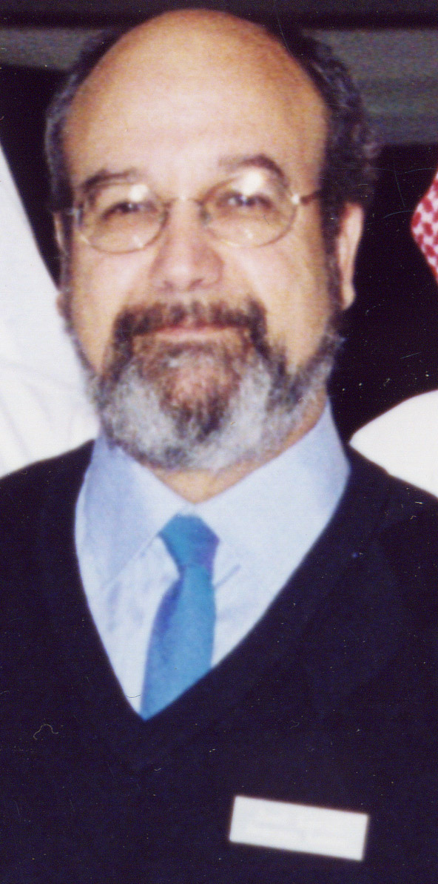
Work Orders. Without work orders, there is no way to go to the next steps. It is important that work orders be generated and supplied in a user-friendly environment to encourage their consistent use.

Computers. Computerization of maintenance came up as a hot topic. People are interested in finding new ways to implement computers in maintenance operations.

Long Term Commitment. Long term, stable funding is a problem in many maintenance management situations, making setting and achieving long-term goals difficult. This is especially true among publicly funded institutions.

Overtime Authorization. If you have a life and limb situation, overtime should certainly be authorized. In all circumstances, however, keeping track of overtime authorization cuts down on any unwarranted use.

Long-Term Budget (see also Long Term Commitment above). It’s easier to keep a budget when you have a five- or six-year plan. Nothing can get accomplished over the long range without a budget. A long-term budget and long-term plan are necessary components of PM.

Head Count. Taking a head count is one of the most popular ways of deciding when the inevitable peaks are taking place, so that a contractor can come in just for those events. This allows for reduction of the overall staff during normal times.

Training. Training is a big problem in the maintenance world because the technology of buildings is constantly changing. Also, training makes people feel as if the company is investing in them, particularly where there is a long-term process for training and “multi-skilling.” This is common in the building and facilities field, but less so in manufacturing. In manufacturing, specialization can result in the need for many more employees, each with a specified craft area.

Cross Training and Productivity. If an electrician is changing a motor, there should not be a need to call in a millwright, a sheet metal mechanic, and a pipe fitter to get the job done. It is most productive for one person to be able to do the whole job. When, for example, an electrician is not allowed to put a hole in a wall to do the job, and a carpenter must be called in, that is simply not productive. Most people would prefer to have the knowledge and training and be able to do the whole job. Providing cross training makes for a happier and much more productive workforce.

Allowing for Employees’ Preferences. There are some people who don’t want to cross the line, and your system must, at times, accommodate them. For example, it can be difficult to find someone who can work on computer software and hardware, and also not mind crawling to the top of a 30-foot tank in a tank farm to work on temperature transducers. It is easier to find an employee who is hired to climb up the tank who will also be willing to work on computers. The computer guys say, “We work indoors, we don’t work outside and climb tanks and get dirty.”

Long-Term vs. Short-Term Gains

When you double the size of an operation and reduce the workforce, what does that mean? It can mean you are:

(1) Outsourcing;

(2) Increasing productivity, or

(3) Allowing deterioration.

The bad news is, in many operations, deterioration is what’s going on. Their priorities probably are not about productivity; rather they are about trying to keep plaster from falling on the people who are working there. It’s an inevitable engineering fact that if you have a facility, building, or structure -- an asset -- it will deteriorate if you don’t put enough money back into it to keep it in a preserved state.

Clearly, this is not “magical thinking.” There is no reason it should be viewed by management as heresy. A lot of times, you can tell management, “If you go below this level of maintenance, your building will deteriorate;” and they will loudly say, “No.” They seem to figure if they yell loudly enough, a basic fact of engineering will change. Nobody has figured out a way to put a big plastic bag over everything and keep it preserved perfectly and forever. Even people who mothball facilities have problems, as shown in the example to follow.

A major oil company mothballed one of its refineries. A refinery is an operation that normally runs with about 300 maintenance people. They allowed only about ten maintenance people during this time. Six years later, the company tried to bring that refinery back online. They had calculated that cost at about $100 million. As it turned out, they were off by $500 million.

The oil company had made a little mistake. When you have a refinery that you don’t maintain -- and ten people is certainly not enough to maintain a mothballed refinery – things go wrong. None of the valves are going to work; the compressor probably won’t work; and there will be corrosion in the power transmission systems because there weren’t enough people to take care of all those things.

So, instead of having 35 or 40 or 50 maintenance people there, the oil company had decided to save some money. Fifty people might have cost them $5 million a year at $100,000 per person per year. Over the six years, $5 million a year would have been $30 million. To save $30 million, the company is now going to have to spend $500 million.

We see this problem all the time, in every walk of life. The attitude behind this day-to-day thinking is, “I don’t want to piss off the shareholders or the analysts and lose that money.” They think, “I can increase my profit by cutting out... Who’s going to remember it six or seven or eight years from now?” This kind of thinking is more often than not the case, as shown in the following example.

In 1981 the Connecticut Turnpike fell down. One of the maintenance managers said the reason it fell down was that it was an elevated roadway and there is a lot of ice and snow in that area. He explained that due to the cold weather, the roadway had been constructed with big pins on which it could expand and contract. The pins had corroded and disappeared, causing the roadway to actually fall down.

The maintenance manager had been looking for about $400,000 a year for maintenance to do lubrication and testing of the pins. Over a period of 20 years, that $400,000 per year would have added up to $8 million. When the road fell down, they had to spend about $300 million to fix it. Connecticut has always had financial problems. Maintenance couldn’t get $400,000 a year for good maintenance practices. Guess how long it took Connecticut to come up with the hundreds of millions of dollars to build the road back? It took them about a week.

This is the battle fought by maintenance every day of the week. Sometimes there is a management team that understands these issues; and, although they are squeezed, they’ll try to get you everything they can. Sometimes there is a management team that doesn’t have a clue, and the maintenance team will need to educate them. One of the ways to do this is through the budgetary process. A good budgetary process translates the information about the use of employees and materials into a language the numbers people can understand and appreciate.

Real Needs and Real Problems

Some attributes that affect the maintenance budget are the size of the building, the type of construction, and the quality of the design. There are buildings in which the design is simply not maintainable. This can be a problem especially in very old buildings, where the construction may include ornamental plastering and ornate cornice molding.

We also face disasters in newer buildings that were designed by architects and engineers who were just learning their trades. The architects and engineers might have learned from their mistakes and will never do that again, but maintenance is stuck. We will need to maintain those buildings for the next 20 years or so. The design of the Connecticut turnpike is an example of this. In 1968, the design was determined to be inadequate due to a lack of structural redundancy. They basically banned the design but were stuck with the road.

Use of a building is an important aspect. For example, in an elementary school building, you’ll see a certain level and type of maintenance. Turn that same building into a senior recreation center, and the maintenance exposures will change dramatically due to the use of the building.

A shelter for homeless families, for example, where a whole family uses a dorm room and there is a cafeteria for meals, is under severe usage. There are a lot of children in the building. Children are just like sandpaper; they wear through anything that’s in their way. They write on the walls, and while that’s normal for children, it’s on the maintenance department to clean it up when you’re maintaining the building. A normal office building would never see as severe use as a shelter over the same square footage.

The knowledge and experience of the staff will have an impact on this picture. You may have a staff that’s relatively less knowledgeable. Maybe they had previously done in-house custodial work only, with maintenance going to outside contractors, and now they have to begin doing all the work themselves. The reverse could also be true. You may always have had an outside contractor do the custodial work and, gradually, the maintenance crew is expected to take on that work. The problem would be the same -- employees don’t have the knowledge and expertise they need in a particular area.
