Maintenance Technical Library (MTL)

By Joel Levitt

Another structure in the maintenance department is the existence of a unified place for technical information. Information is one of the essential elements of maintenance work. In the past, the MTL has been in a support role to the major items (such as planning). Over the next few years it will become one of the leading elements. It is the height of fat to arrive at the job with everything needed except the wiring diagram!

Information is stored in the maintenance technical library. The maintenance technical library is becoming increasingly virtual (meaning it exists where ever there is a connected computer). Even with an Internet or Intranet based technical library it is great to have a place where maintenance technicians can have access to a computer and printer. We would like to see the MTL in a place which shares space with the Lean teams meeting area.

Have you noticed that effective maintenance is increasingly based on information rather than skills? Having the right settings, diagrams, and drawings simplifies maintenance work (makes it possible at all). Of course the old timers kept a greasy notebook with all that critical information.

In the world of ISO 900X the greasy notebook is problematic. We need to be able to manage versions. We need to know what information is on the floor so we can issue revisions when necessary. So where is this information when we need it most?

The Maintenance Technical Library (MTL) is the concrete or virtual home for detailed maintenance data. Increasingly the maintenance technical library is becoming virtual (meaning it exists on a hard drive somewhere and can be accessed where ever there is a connected computer).

But even with an Internet based technical library it is great to have a place (call it the maintenance technical library) where maintenance technicians can have access to a computer and printer. They can then use the local network or the Internet to look up repair history jackets (CMMS), equipment manuals (document management or OEM), parts lists, assembly drawings.

In a recent project we are helping a company build a parts storeroom. As part of this project we are helping them populate the Bills of Materials which will tell them which every part and which machine they go to. Since we were into every OEM manual to find the parts list I asked if we couldn’t capture the exploded parts diagram and attach it to the Bill of Material. This virtual parts drawing would be invaluable in tracking down part numbers.

Other things in the MTL
One good idea for the MTL is a display cabinet for broken parts, bearing and other small items. A display where you can pick up and handle burned bearings, fatigued brackets and other worn items can be a powerful teacher for new workers, plant people outside maintenance and even maintenance old timers. Clean them up and label them. You’ll find people can’t keep their hands off of them (but learning is happening!).

The photograph shows a display case of broken parts with information cards.
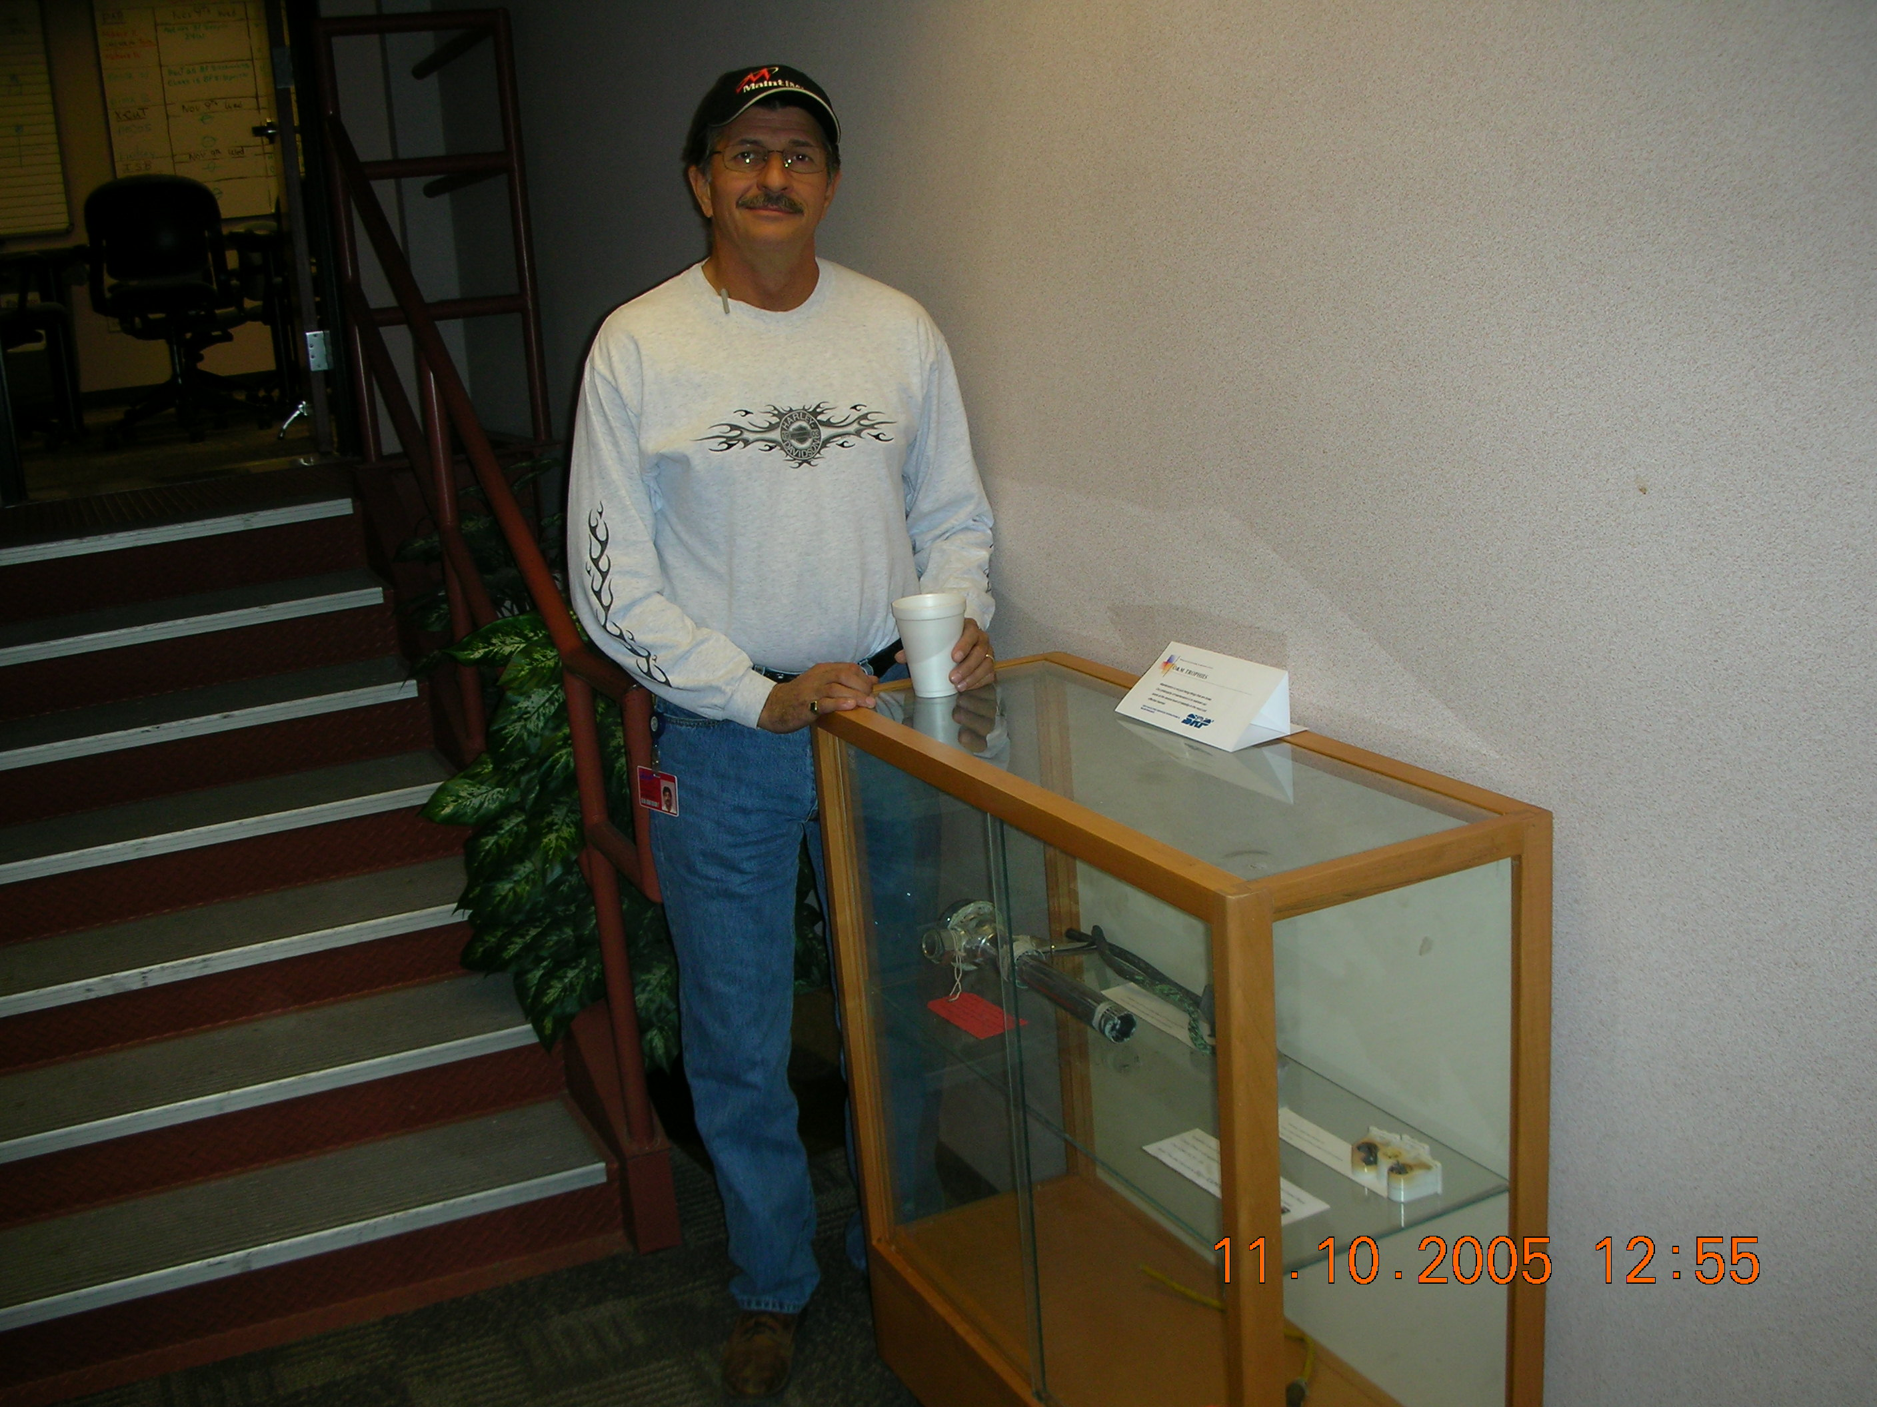

In addition the MTL should be the location of a copy of plant drawings, site drawings, vendor catalogs, handbooks, engineering text books, etc.
If you have computerized maintenance, stores or purchasing, CADD, CAM then access is located in the MTL.
If you’ve attended my classes you know I like to see economic analysis of PM task lists, justifications of shutdowns, protocols for analysis of data and other paperwork exercises. The MTL is a great place for these analyses.

Considerations
- Explicitly check if backups are being made of the files of the CMMS and MTL data. Normally the IT department is already pretty good at this but it doesn’t hurt to ask.
- Protect from paper files from fire, flood, theft (consider fire proof file cabinets and off site storage of copies)
- Use some kind of sign-out system if material must be removed
- Make it someone's responsibility to keep it up to date.
- Manage the revisions so that all copies are updated (coordinate with ISO 9000).

When the MTL is set-up you will have: A ready reference for make verses buy decisions, Repair history, repair parts reference with history, repair methods referral, planning information source, time standard development, data bank for continuous improvement efforts, maintenance improvement team headquarters.

The Internet is now everyone’s Maintenance Technical Library
There are several ways the Internet is being used for maintenance information. The advantage is that the capabilities are available around the clock, 365 days a year (as long as you can get access to the Internet).

