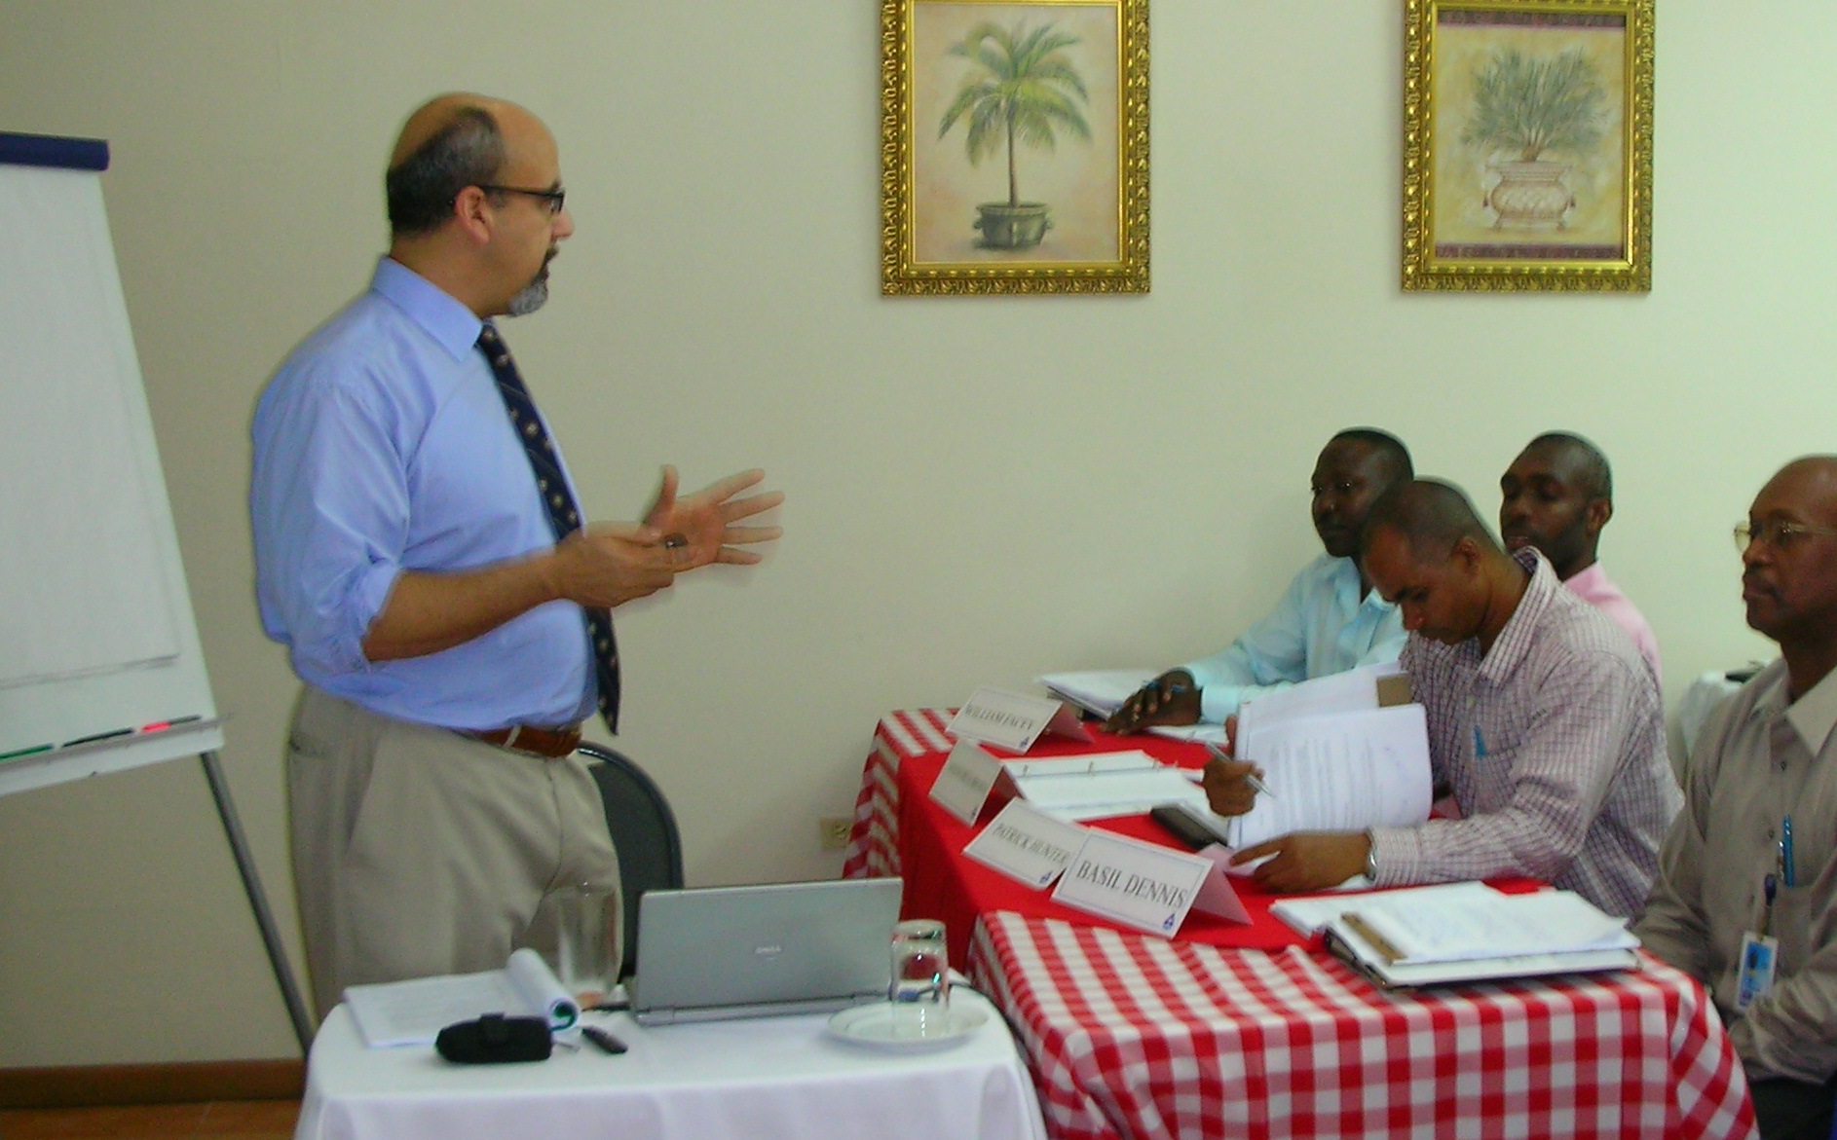
A Universal Management Tool

I just had the opportunity to attend a Root Cause Analysis (RCA) class in Australia. Run by SIRF RCA (http://www.rcart.com.au ) for a port coal loading facility. This port stuff was big. The piers could load 8000 tons of coal an hour into ships bound for China. Ten hours per ship and 3 ships at a time!
In the class were the Port’s maintenance mechanics and electricians. This was significant since I thought it would be managers and engineers. The students were told to bring to the table various problems that they saw in their every day maintenance life. The instructor, Bernie Piovesan led them through a structured learning experience where they eventually got to address the issue they brought to the table. Using flip charts and Post it Notes® the teams wrestled with the causes to their problem (no need for fancy software but it does make it easier).
As the teams struggled with the RCA steps they started to travel down the roots of their various problems. People’s faces lit up as they started to see the roots of their problem and what they could do to solve it forever. The instructor had to hold the people back from jumping to conclusions because the discipline helped find more universal causes.
After that class I thought this RCA must be pretty powerful and started to train myself in the approach. Since I talk about Lean Maintenance, Operator maintenance, PM, and other topics a universal approach to solving problems would be universally useful.
I saw RCA as sort of a universal tool (like a pry bar –you can use it for lots of different things). Think about this; if there was a management tool that is a key to PM improvement, RCM, continuous improvement, lean maintenance, TPM, troubleshooting and safety and could and should be applied by workers, wouldn’t you want to learn it? It turns out there is such a universal tool and it’s called Root Cause Analysis (RCA). Simply speaking RCA is a structured 3 part approach to first evaluating the consequences of the problem while isolating the problem, finding the causes of a problem and lastly intervening to stop that chain of events that caused the failure or accident.
According to Bernie Piovesan, while we call the process Root Cause Analysis it might be more properly called just Cause Analysis because generally there are multiple cause trees or sequence of events that lead to the any substantive failure under analysis. Each failure or event has several cause trees and several potential causes. An intervention in the cause tree that is economic and stops the failure and has no bad unintended side effects is the Root Cause for our purposes.
Why call it a universal tool? Maintenance could be said to be made up of a hundred problems a day. Good maintenance professionals can solve most of them at the first shot without too much suffering. But typically there are some problems that defy the easy way and lend themselves to a more structured approach. There are also problems that we fix the symptoms of but never get deep enough into to solve forever.
What if one class of trucks got significantly lower MPG and consumed tires faster than other units of the same size? We might just change the tires more often and yell at the drivers to be more careful. Using RCA we would first figure out how expensive the problem is. Then we would identify all the causes and look at the causes of those causes. The causes of the causes become the cause tree. The key is to look closely at what intervention will interrupt the cause tree and eliminate the problem forever (or significantly reduce the probability of the event).
RCA teams consisting of 3-6 members are usually convened ad hoc for a particular problem. The team benefits from a diversity of members. Piovesan stressed that people from outside maintenance were needed because someone has to ask the dumb questions (to question all the assumptions). Outsiders from operations, drivers, marketing or even accounting are useful members of an RCA team. Some members of the team need deep knowledge of the process being studied.
The crazy thing about RCA is that it is fun. Get your people some training and try it, you might like it!
Joel Levitt
JDL@Maintrainer.com

