How to measure the performance of maintenance activity
By Joel Levitt
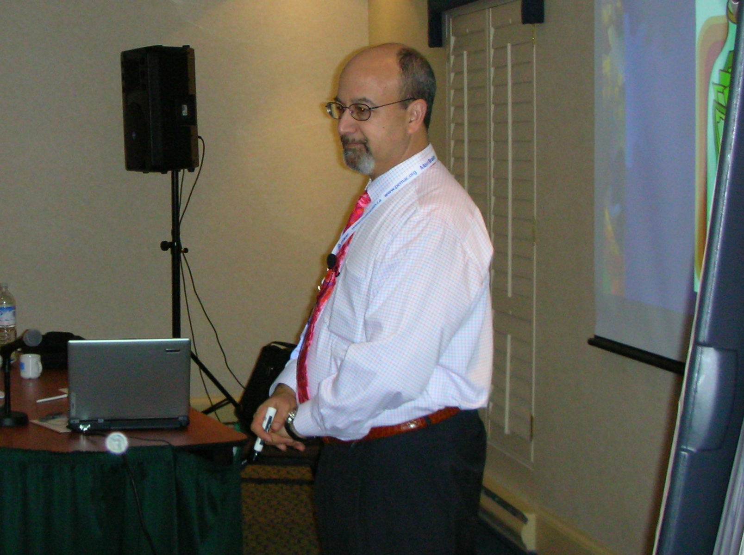
Performance can be measured through the use of standards for maintenance work.. The driving force has been the increasing need to contain and control maintenance costs.

Reasonable returns should be expected from investments in job standards. A maintenance shop should balance its investment with the potential returns available. Certainly non-repetitive jobs of short or moderate duration do not require standards unless the timing of the return of the asset to service is critical. Repetitive jobs such as PM tasks and repetitive corrective actions are well suited to standards.

There are four ways of developing standards. These different ways can be used together to create a unique set of standards for your facility.

1. Estimate: Estimates are educated guesses.
2. Historical standard: The elapsed times that it takes your personnel to do individual jobs.
3. Direct observation: Two approaches called methods engineering (ME) and reasonable expectancies (RE).
4. Published standards: Published standards are published by both public organizations and by private companies for profit.

When seeking standards, look first to the manufacturer of the equipment or material. Other places to look include experienced trade’s people, your own written history, contractors, and consultants.

Many facilities have computerized their work order system, inventory control, and PM task list generation. Most of the over 100 maintenance packages (called CMMS, Computerized Maintenance Management Systems) support some level of standards usage.

The minimum level of support is a field on the work order called estimate. When the work order is opened someone is expected to enter the description of the repair. They are also expected to manually add their best estimate. With these systems there is no attempt to manage the standards themselves or automate the assignment of standards to jobs.

Some CMMS support standards to a slightly greater extent. In addition to a field on the work order there is the ability to store repetitive jobs under a code. The code for an annual PM on an air conditioner might be PMA-A/C-01. Anytime that job is called up, the estimate comes with it. These named jobs do not have to be PM jobs only. Any job can be pre-planned, entered and have a code assigned.

The third level of support to look for is the recording of performance against the job descriptions or job codes. Some systems have the ability to track and calculate historical standards and keep these numbers on file for reporting, job analysis and employee comparisons. Some will develop the mean time to repair for all jobs.

High level systems help manage the standards with standards assignments, modifications, histories and performance tracking. Several systems keep two different types of standards for each job. The historical standard is updated by the system every time a repair is completed. The second doesn't change with the jobs. This allows the supervisor or manager to set performance goals using outside standards that don't change.

Why have standards?

Scheduling
The advantages of labor standards in scheduling are in the areas of efficiency, morale, and customer service. "You can schedule your people or you can let breakdowns; or irate, bored or lonely maintenance customers schedule them. One way or another, your people will be sent to jobs every morning." (From The Handbook of Maintenance Management)

When the start time is known, the other elements of the job can be coordinated. Maximum efficiency requires bringing together, in precise timing, the six elements of a successful maintenance job: the mechanic, the tools, the materials, the information, the availability of the unit to be serviced, and the permission to proceed.

Efficiency can be improved by scheduling several jobs together in one end of the facility. By knowing how long jobs take, fill-in jobs can be added to a large job to fill out the day at that location. Efficiency can be gained by grouping jobs together that use the same materials.

Some jobs go bad. Due to hidden problems, inadequate skills, defective materials, or inadequate tools a job might take twice or longer then it should. If a large repair is falling behind schedule, interventions can be instigated. Interventions when the job is running can correct the problem and prevent a complete disaster.

People work at a pace that is partially based on the amount of work they are given. Schedules based on standard hours free workers from a hurry-up atmosphere one day and a kill-time atmosphere the next. Back-up jobs are given so an employee can move to another job if they are impeded by a lack of parts or tools. Consistent flow improves both output and quality.

Long term planning of repetitive work
Preventive maintenance (PM) task list work, routine jobs, and scheduled equipment replacement are repetitive jobs that have to be completed on an ongoing basis. If PM type jobs start to exceed a percentage of your available hours then the natural tendency is to let them slip in favor of urgent jobs.

Yearly planning using labor standards can reduce the need for overtime and contractors. It will also insure that there is enough time for your PMs to get completed within the month they are scheduled.

Employee evaluation

Analysis of an individual’s work could prove who needs training, re-assignment or to look for another job. One performance measure compares the hours reported on the work orders against the standard hours for the same repairs. This measure is focused on the mechanic's ability to complete maintenance tasks. It does not measure the job quality (which would have to be looked at separately).

A second measure adds up all of the standard hours accumulated in a week or month and compares that number to payroll hours for the same period. This is a measure of the maintenance delivery system because all lost time is included in the comparison. The department's ability to assign jobs, communicate critical information, get parts to the workers and get rooms unlocked is being measured with this type of metric.

Budgeting
Time standards can positively impact the budget process. Time standards allow the facility manager to answer the question, how much will it cost to maintain a new building, machine, product line?

Morale builder
Feedback maintenance workers get is more related to the customer's mood then the speed or quality of their work. Standards help by providing the mechanic with the expectations of management. When the mechanic can keep up to the standards, then they know they are doing a `good job' by management's definition. This specific feedback improves morale.

Customer service
Accurate estimates improves your customer service and increases the value of the service you perform for your users. Good customer treatment requires the supervisor being able to answer the question "when will the maintenance worker get here?" and the related question "when will my repair be completed?" A schedule will lay out the standard times for each mechanic and can estimate when he/she will be available to work on the customer's job.

Systems of Standards

All types of work standards should be based on:
1. Similar types of equipment (like equipment in like service) should be grouped together.
2. Concise description of repair or PM tasks performed
3. Description of what work was accomplished
4. Easy access to the room or area to work on the asset.
5. Number of people required (crew size).
6. Location of the unit repaired
7. Complications and extra work should be recorded by the mechanic. Written up work is usually added on a standard hour per work hour basis.
8. Standards are usually based on a skilled and professional tradesperson, with the right tools in the right place at the right time.
9. Factors like age, gender, and years of service of the mechanic, time of day, and parts cost are not considered in labor standards.

Estimate
By far the most common type of time standards are estimates made by supervisors, craftspeople and planner/estimators. Anyone involved in maintenance has been asked how long it will take until this bathroom is fixed or this building is cool. The answer is an estimate.

Slotting method of estimating: Slotting compares the job to be evaluated to a group of well known and studied jobs. The supervisor determines where the job fits in (which slot). Is it bigger then slot 2 but smaller then slot 3? The time estimate would be between the two. Usually it is easier to determine whether a job is bigger or smaller then another then how long it would take.

Your slot chart could be broken up by craft and have 7-10 entries. The standard jobs could be picked by the trade’s people after a short discussion.

Historical Work Standards
Just about all computer systems track the time it takes to do a job. Some systems can evaluate all of the repairs of a particular type on a particular type of equipment. These standards can be useful since (unlike the engineered rates) they factor in variables such as the actual condition of your equipment, the skill level of your work force, the layout of your shop, and your tools and equipment.

The disadvantage of historical standards is the accuracy of the data collection. For example, the work order might read `Fix pump'. The mechanic might have to check valve positions, motor circuits, and source product before accepting that there is even a problem with the pump itself. All of these activities are lumped together in the historical standard.

Most organizations do not insist on accurate descriptions of work accomplished. Without detailed descriptions historical standards will be averages of very different jobs. If all toilet jobs were lumped together, the range of jobs might be from minor float adjustment to removal and replacement with a rebuild to the floor!

Schedules based on historical standards include a full amount of lost and wasted time. When an employee is talking, eating or not at his/her job for any reason the time is still charged to the repair and will find its way into the historical standard. Published standards don't usually include lost time but don't take into account conditions and skills of your crew.

Direct observed standards
Direct observation has two different approaches. The micro approach is called methods engineering (ME). ME has two roots called time study and motion study. Time study breaks the task into units and precisely times each element. The father of modern time study was Frederick Taylor. Taylor worked in the late 19th century. It is hard to imagine today, but the concepts were so controversial that in 1912 the US Congress conducted a full scale investigation of the field.

Motion study can trace its history back to the same era with a husband and wife team, Frank and Lillian Gilbreth. The Gibreth’s studied motion in a laboratory and broke it into its basic elements. These elements, called therbligs (Gilbreth backwards), are still the basis of motion study.

The problem of ME is time. It might take a week or more to fully analyze a single repair. It is a time consuming process that results in accurate estimates when it is applied properly.
The time study person is an industrial engineer who breaks down the job into simple motions and times each section.

The second method of direct observation is a macro approach. In this method a person would observe the whole job at once and record the work time. They do not use stop watches. The standard developed is called a reasonable expectancy (RE). The RE is usually based on several observations.

The concept of reasonable is important. By observing several craftspeople doing the repair you have a good idea of how long it should reasonably take. No speed-up is needed to improve productivity. REs will improve productivity by recapturing time lost in non-productive and marginally productive activities. REs can be done by anyone. It does not take extensive training to directly observe a repair with enough accuracy to set a standard.

Published Standards
Standards are published by organizations for their own use (many contractors have developed standards for their own use in preparing estimates), by equipment manufacturers or by third party for-profit publishers. The most wide spread and oldest standard is the Engineered Performance Standards (mentioned later). In all cases, the skilled mechanics with proper tools should be able to meet or exceed the published work standard.

The reason that published standards are essential in the mix is the clarity brought to the situation by an outside, impartial source of productivity data. The published standard was developed somewhere else by, presumably, expert mechanics observed by expert observers. This outside opinion is a good check on the skill and veracity of your own crews.

Engineered Performance Standards
The engineered performance standards of the US Navy are the oldest set of labor standards in use. They were developed starting in the 1950's.

It took 10 years before the first version was ready for use. During the development phase, the Navy set-up in NAVFAC, an industrial engineering group to accomplish this task. Each of the 13-14 engineering field divisions was assigned a craft to analyze. At the project's peak, 200 industrial engineers were working on the project nationwide.

EPS is based on the actual pure work content of the job. Factors for travel, preparation, delays were added based on the trade and the location of the job. The standards were aimed at maintenance and repair functions and not installation or construction.

One of the advantages of EPS is their availability. The US Government has the standards available through the National Technical Information Service. To order, call the NTIS sales desk at (703) 487-4650. All of the documents start with: Engineered Performance Standards Public Works Maintenance.

R.S. Means Maintenance Standards
R.S. Means is the largest publisher of information on estimates and standards for the facility manager. Their specialty is building construction.

One of these books, Means Facilities Maintenance Standards, by Rodger Liska lists over 180 standards for common maintenance tasks. His 575 page book goes well beyond time standards to include PM task lists, listings of tools and techniques, and information on managing a facility maintenance department.

The roots of this book stretch back into the late 1970s. Rodger Liska, now a Associate Dean of the School of Architecture Arts and Humanities of Clemson University in South Carolina, was asked by AT&T to look into its building maintenance practices. He created a course of study over a several year period that became the predecessor to the Means Facilities Maintenance Standards book.

He feels that all standards systems have to be adjusted for the particular facility. His advice to maintenance managers is to start with published standards and gradually create your own standards for your unique situation.

How to setup a standards system

1. It is imperative that your work order system is accurately reporting detailed job descriptions and actual time.

2. Enlist the help of the mechanics in the overall design of the program. The goal is to accurately predict when a job will be complete. The secondary goal is to smooth out the work flow to the workers, not to increase the amount of work.

3. Standards usage can be started on a pilot basis. Start with an area, equipment or activity that is easy to isolate and consumes a good deal of time. This could include frequent PMs, routine jobs (such as filter change routes), or common repairs.

4. By far the easiest place to start is with published standards. For a few hundred dollars you can obtain copies of all of the R.S. Means or EPS books.

5. Start off assigning standards to all PM task lists and all repetitive work. Also as work comes in against your pilot area, assign standards from the books.

6. When completed work orders come back, note performance against the standard. The actual times (as reported on work orders) are the historical standards. In the beginning you will start with 3 columns; the published time, the historical standard and the observed time for each described repair or PM.

7. Observe of some of the more common jobs after getting historical standards back from the field.

8. Compare the published standards, REs and historical standards on jobs where all are available. Seek any patterns between the standards.

9. Determine the relationship between the different standards and determine factors for assignment for your facility, crews, and tooling. Scheduling and job assignment should be based on the most realistic of the standards with or without extra factors.

10. Continuous improvement based on improving upon the standard is the goal. Re-engineering the maintenance task or machine, re-tooling, re-deployment of parts or people might be necessary to achieve the goal. The best mechanics can train the others in their technique for common jobs.

This article is based on excerpts from:
Handbook of Maintenance Management by Joel Levitt published by Industrial Press
Facility Manager's Operation and Maintenance Handbook edited by Bernard Lewis, Partially excerpted from chapter on Engineered Performance Standard Usage Plan by Joel Levitt to be published by McGraw-Hill


