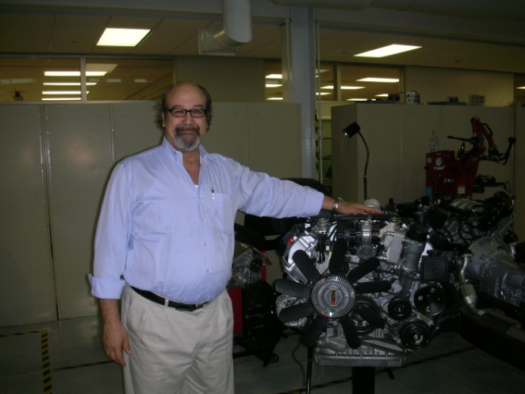**Address at SABIC:**

**Safety and Reliability**

By Joel Levitt ©2011 [JDL@Maintrainer.com](mailto:JDL@Maintrainer.com) words 1877

Process safety contributes to reliability as reliability contributes to process safety. For 20 years SABIC has been a global leader in process safety. The institution of your SHEM program has been a great success and has reduced the number of incidents dramatically. The core of the program is its focus on all aspects mechanical integrity.

Under the SHEM program SABIC has integrated Process Safety, Environment, Health, Occupational Safety, and Emergency Preparedness & Response and security into a unified program of systems and standards. This event is a celebration of accomplishments in these areas.

Clearly the rest of the world has to catch up. In the US during a three month period in 2010, 58 workers died in explosions, fires and collapses at refineries, coal mines, oil drilling rigs, and power plant construction sites.

In his address to the National Petrochemical and Refiners Association National Safety Conference in 2010 *Jordan* Barab, who is the Deputy Assistant Secretary for Occupational Safety and Health said “The headlines of refinery worker injuries and deaths on the job and of OSHA's stepped-up inspections are sounding an alarm about an industry-wide problem -- a problem that we are obliged to address. Bluntly speaking: Your workers are dying on the job and it has to stop.”

What it comes down to is *organizational culture*. Professor Andrew Hopkins a global leader Petrochemical safety of the Australian National University says workplace culture is not just an educational program that gets everyone to be more risk aware and think "safety first." Hopkins and the Center for Chemical Process Safety have defined culture simply as "the way we do things around here."  
  
Unlike the rest of US industry the petrochemical and power utilities cultures are well along their process safety paths. In all of industry in the US in 2009 there were 4,340 deaths. The injuries suffered by US workers are even more startling:

Total recordable cases: 3,277,700

Cases involving days away from work: 965,000

Cases involving sprains, strains, tears: 379,340

Cases involving injuries to the back: 195,150

Cases involving falls: 212,760

Think of it, when we fix some of the root causes of the fatalities or injuries whether they are caused by behavior, culture, design, process or procedure more workers will go home at the to their families whole and intact. There are many reasons for these injuries and fatalities. Defects in mechanical integrity and neglect of process safety are foremost among them.

I want to discuss the maintenance oriented injuries and fatalities. Some examples of serious accidents from OSHA records:

* A massive explosion destroyed a large storage tank containing a mixture of sulfuric acid and flammable hydrocarbons at the Motiva Enterprises Delaware City Refinery. One contract worker was killed, eight others were injured. Sulfuric acid from collapsed and damage tanks polluted the Delaware River. The explosion occurred during welding operations to repair a catwalk above the sulfuric acid tank when flammable hydrocarbon vapor was ignited by welding sparks.

In this Delaware City explosion we can see a lack of an effective inspection for mechanical integrity SHEM-07 (of the catwalk) and a general disregard for safe practices SHEM-08 which points to a void where process safety should be. Of course this is not a substitute for proper incident reporting, investigation and root causes analysis.

* Crews were doing maintenance work on a generator while a pressure test was being done. That's when a man way blew off, after the compressed air inside was released, striking two contract workers injuring them critically.

We can imagine that the workers and their supervisors did not see the risk. Under SHEM-03 the maintenance procedure would have worked through and the hazard would have been detected in SHEM-02 and would have been mitigated or eliminated.

**Why did these injuries occur?**

Generally accidents are grouped into 5 categories. According to Barab’s address mentioned above, the areas are spread among many parts of the business.

**Category SHEM section covering % of accidents**

Operations and maintenance SHEM-03, 04, 05, 07. 08 15%

Design and implementation SHEM-07 15%

Installation and commissioning SHEM-06 6%

Specification SHEM-07 44%

Changes after commissioning SHEM-09 20%

At SABIC the top leadership of the enterprise has been involved since the program’s inception. It is essential to have a safe culture nurtured from the top of the organization because environmental, safety and health thrive in environments where management requires that they be reviewed at every step from the initial design to the plant process and procedures, even to the hiring of qualified operators and maintenance personnel.

I want to focus on reliability of equipment. Problems in all the categories above can be causes of breakdowns. Not managing mechanical integrity is the leading cause. For example, in operations and maintenance a culture of expediency (where process safety steps are not followed reliability) can contribute to procedures not followed, design flaws and workers not being careful. With all that going on in a typical petrochemical plant it is easy to see that non-standard situations (read breakdowns) can also occur. Remember Professor Hopkins mentioned earlier the culture how we do things here and is the sum of everything including all the decisions made, attitudes and history.

Some of the accidents are the result of unsafe acts (hot work on a tank with an explosive mixture inside without mitigation), failing to follow procedures (pressure testing with personnel in harm’s way). Of course, most accidents like these have several causes at the same time.

Reliability, mechanical integrity, and process safety are all profoundly linked. How they are linked is a rich vein of inquiry. One way is very simple and might not occur to maintenance professionals. This reason is at the core of a high percentage of accidents. If we look at more maintenance related fatal incidents we can start to see a pattern.

* A tragic double fatality of welders on a petrochemical plant when an argon cylinder had been left leaking into the vessel they were due to work on. The first one went in and collapsed; the second, instead of raising the alarm first, went in after him, and they both died.

Right before you enter a vessel you test the atmosphere. That would be a well-established safe work practice and part of Process Safety. The second issue is that when someone succumbs in a confined space safety first responders are alerted immediately and you are never to enter the area without a harness, air supply etc. This would also be covered by safe work practices.

**The simple pattern is that something was broken and had to be repaired! The breakdown caused the person to go into harm’s way.** So lack of reliability can be a cause of death and injuries. If mechanical integrity is managed this cause goes away.

Reliable equipment removes this cause --one of the common causes of accidents. We could be even more specific. Equipment running as designed does not require people to enter a confined space, repair (and touch) exposed electrical wires, pressure test a generator, sitting on top of a tank and welding, or even falling off of a ladder.

Reliability removes one element of risk from the equation because the worker is not in harm’s way. If no one was welding above the tank then the explosion would not have happened, if there was no repair needed no one would be up on the ladder or on the roof.

**Reason 1: Reliability reduces the need to put one’s personnel into harm’s way.**

The second part of the equation has been reported by Exxon-Mobil. They studied their maintenance related accidents and found: “Accidents are 5 times more likely while working on breakdowns then they are while working on planned and scheduled corrective jobs.”

High reliability implies a mechanical integrity program. One part is an effective PM program that catches deterioration before it causes a failure. Since the asset is not yet broken it is safer to work on.

**Reason 2: Size and scope of repair is smaller (due to PM) making for safer repairs**

High reliability also implies that the maintenance planners have time to properly plan the job. One aspect of planning is to consider all the hazards and figure out and describe a way to accomplish the work safely. The job plan that an experienced planner develops will reflect the safe way to do the job.

A planner should look at every job and see if any common hazards are present. Hazards would include: Airborne contaminates, fall from heights, Slipping and tripping, Falling objects, Eye damage (particle, chemical, and flash), Chemical (ingestion, skin exposure, breathing), Asphyxiation, Radioactive exposure, Fire, Explosion, Electrocution Entrapment and crushing, Temperature stress

Every hazard identified is then eliminated (best option) or mitigated (second best option). The safest plants are the ones where the safety of the workers is considered at every step in the job preparation process.

**Reason 3: Hazards are eliminated or mitigated in the planning process**

One of the building blocks of a reliable culture is adequate maintenance planning. Without planning the workers are forced to make do with what spares and tools they can find. To do their job they may have to improvise to make things work. Improvisation might be great in the theater but can be deadly in maintenance. My guess is that the following worker was making do with an improvised support:

Worker was performing maintenance on the back of a trash truck.  The support gave way and the tailgate came down on the worker.

**Reason 4: Planned jobs allow fewer opportunities for the maintenance worker to improvise. Improvisation is statistically less safe than following the job plan with the correct tools and spares.**

**Either you can schedule your maintenance activity or your machines will!**

It could be said that high reliability is part of a bigger picture of intentional maintenance. That is where the maintenance effort determines its own schedule and not the breaking machines.

Reliability is the outcome of this intentional maintenance environment and is essential in a safe environment.

**Action items**

Mechanical Integrity programs are difficult to measure directly. Management action items to transform the culture require minor modifications to the weekly and monthly KPI (Key Performance Indicators) used to run the plant or facility and for bonuses.

1. Ratio of emergent maintenance work to planned and scheduled maintenance work should be maintained above 80% planned and scheduled.

2. PM performance above 95%. More than 95% of the PMs generated are completed in +10% of the PM interval or 30 day PMs completed in between 27 and 33 days.

3. Schedule compliance above 85%. That means more than 85% of the jobs scheduled are completed sometime the week they are scheduled.

4. MTBF for major assets on an improving trend

What if one of your plants doesn’t measure up? Then it is time to talk through the problem, study your best plants and consult experts. However changing a culture takes time and will take three attributes:

* Follow-through to keep people’s eye on the goals
* Resilience to get the plant back on track when the program goes off the track
* Positive attitude – Just like teaching a child to ride a bike keep up a positive encouraging attitude. Don’t punish honest mistakes; make sure your people learn from them.

Good luck

Joel