How to sell administration on adequate maintenance resources
By Joel Levitt

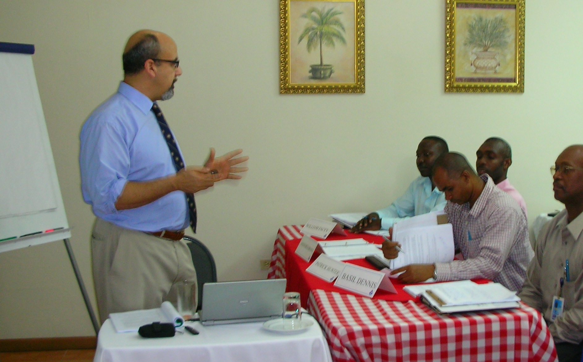
Try creating a Maintenance Work Program

The maintenance (physical plant, etc.) departments in education are under tremendous pressure to provide services to larger and increasingly complex campuses. Constant building without regard for appropriate crewing has caused a widening gap, which increases backlog and deferred maintenance. The cause in many cases can be traced to the willingness of major donors to fund building and the relative unwillingness to endow the maintenance and upkeep of the same buildings. Maintenance and physical plant professionals are caught in the gap with the square footage but without the staff necessary to take care of it.

Burying your head in the sand is particularly problematic if you happen to be on a railroad track.
Can you see the train coming? It looks like a second-class campus leading to reduced enrollment, kids and the public getting hurt, and increasingly dangerous deferred maintenance items that are deteriorating at increasing rates.

In building maintenance, plumbing and electrical systems deterioration acts like a roller coaster. The deterioration slowly builds and builds over a year or more (or decades or more). When it reaches the critical point you can just hang on for the ride. The solution is not as much fun as a roller coaster but help get you off the ride. It starts with an assessment of what is needed to maintain your campus.

The Work Program is a realistic determination of the labor needed to maintain a particular facility. You create the work program by analyzing the amount of work to be done by category and the amount of labor available to complete the work.

Step 1 is to determine the hours available for work by craft. You do this by adding up the amount of time everyone is paid for and subtract vacation, average absenteeism, training time, jury duty and everything that pulls people off jobs. One of the traps is not to include time away from the job. In informal studies in education the average worker is paid for 2080 hours straight time but is available for work only 1600 or fewer hours.

Step 2 is to add up all of the hours for PM tasks needed to properly maintain the equipment and other routine work. Only use your history as a guide unless you have 100% PM compliance. Actually list out the PMs needed for each class of equipment and asset and expand them by frequency (monthly, quarterly, etc.). This breakdown should include craft requirements unless you are truly a multicraft shop (very rare).

Step 3 is to look at the amount of work needed to provide timely backlog relief. Backlog comes from all sources including the PM group (called corrective maintenance). It is the total of all work not including emergency jobs. Backlog jobs can be planned and should be scheduled for maximum efficiency. Scheduling cannot take place effectively if the resource allocated to backlog relief is allowed to be interfered with!

Step 4 is to look at your historical records for the amount of emergency work for that month or quarter last year. Correct that for new facilities that weren’t on-line last year. As the backlog and PMs are completed in a timely manner the emergency hours will naturally start to decline. You might start in the 30% range and end up in the 10% range.

Step 5 is to add hours to bring assets up to standard. This item covers rehabilitation, remodeling and renovation. Bringing assets up to standard will also reduce emergency work orders (and in many cases will take a bite out of the backlog as well).

The Work Program goes to top administration officials every quarter with trend charts
The Work Program document tells you what is needed in the real world. Where there is a significant shortfall, contractors, overtime or some other solution (such as making a deal with some of your just retired people) will be necessary.

Consequence Driven Maintenance
Every decision to properly maintain a campus has consequences such as an improved look and feel to the campus, improved morale, reduced lost time for workers, reduced interruption to the teaching process, reduced claims from the public against the organization and a myriad of lesser consequences.

It won’t surprise you at all that not funding the Work Plan also has consequences. Look at each of the consequences above and see the negative. These include such consequences as a degraded look and feel of the campus or increased interruption to the teaching process.

Administrators will not necessarily believe you the first few times through the exercise. Help them by collecting case studies of breakdowns that would have been corrected if you had people to take care of the PM or backlog items. You can gather these stories from your own campus (remember your digital camera) and from the trade press. Major catastrophes make it to the general press and can be very persuasive.

If you would like additional information on the Work Program please consult the author’s book Maintenance Planning, Scheduling and Coordination, Industrial Press in New York http://www.industrialpress.com/catalog.asp (and of course, Amazon.com).


