World Class Maintenance for Buildings and Facilities
By Joel Levitt, President
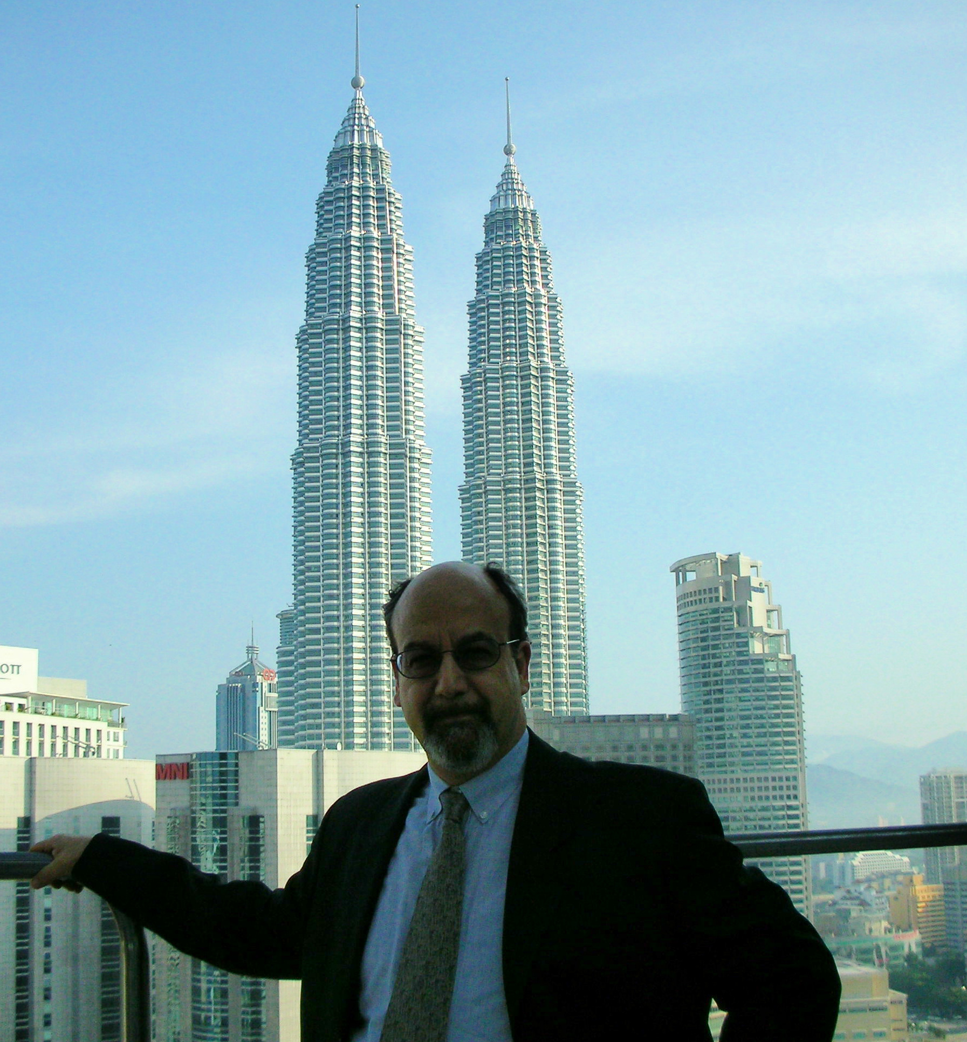
There are a couple of really important points to make at the outset. They are preservation of the physical asset and public and environmental safety. Well-maintained buildings and facilities are better for the environment and for the safety of the public, your employees, your tenants, or whoever uses the facility. The second important point that goes hand in hand with that is, good maintenance practice is less expensive over the long haul.

It is characteristic in the maintenance world that you need to spend a little bit of money over a long period of time to save money, rather than wait for the larger expense of meeting needs only when there is a catastrophe. It will always be more expensive to deal with a catastrophe than to deal with the day-to-day maintenance costs.

Maintenance management will help preserve physical assets. It increases the level of service to clients, whether they are students, manufacturing operations, or tenants. Good maintenance practices increase the level of service. When you manage the labor, parts, and supplies of a resource, more of it will end up in the customer’s hands, improving the customer’s situation.

Quality of life is another benefit of maintenance management. Maintenance people in an uncontrolled maintenance environment have an excessive number of emergencies, calls in the middle of the night, interruptions to ongoing jobs because of crises everywhere. I think that promotes a lowered quality of life. A higher quality of life results when you get your situation organized. However, even with well-organized maintenance, crises do occur, like vandalism or other kinds of inadvertent damage, or even sabotage.

No matter how much preventive maintenance (PM) you do, you will still have occasional emergencies. The differences could be going from a hundred emergencies a month to two or three a month, improving the quality of life for yourself and for your maintenance crew.

The Excitement Junkie

One battle you are fighting in the maintenance world is that the people who actually do the work may be “excitement junkies.” An “excitement junkie” is someone who likes to jump in the ditch and clean out the sewer pipe, especially if it goes through the night, because that’s exciting. In an otherwise drab life, they get these exciting situations where they get to solve problems in a major way and hold up under pressure. A lot of people love that kind of stuff. You need to really watch out for that. When you begin to organize, you will be making it a boring environment for those people, or maybe for yourself. We need to figure out a way to channel that energy.

“World Class” Maintenance

What does a world class maintenance department look like? If you were in the best possible shape, in what shape would your department be? If we were to compare you to the best in the business, how would you stack up? Look around and see who has the best operation, and it won’t necessarily be the best funded. Look at universities, for example. Where is the best operation based on cost per square foot or cost per student? What does that operation look like?

A world class operation is so good at what they do, they improve the effectiveness of the underlying organization and contribute to it in a big way. An example of this is UPS (United Parcel Service). It is commonly known that their maintenance department is so good that they contribute to the competitiveness of the entire enterprise. UPS has a level of reliability of their equipment and low cost of maintenance to the point where they can deliver a package for less money than anybody else and do it more effectively. That’s world class.

Mission Statement and
“Constancy of Purpose”

Does your maintenance department have a written statement? This should not be stuck up on some boardroom wall. Employees need to know there is a mission statement and what it is. A mission statement is or should be a common part of the culture of the organization.

Do you have constancy of purpose? In other words, do you have a maintenance effort that is relatively constantly funded and organized toward getting the job done? In Louisiana, the Army Corps of Engineers has figured the design life of a dam and lock on the Red River to be 175 years. They have component change-out programs with 35- or 40-year cycles.

Can you imagine your maintenance situation being such that you are predicting and planning events for 35 years in the future? That is constancy of purpose. In the ideal maintenance management, we have the schedule set up; we know we’re going to need something seven years from now; it’s planned; it’s budgeted; and it’s funded.

The most debilitating situation for maintenance is “flavor of the month club.” That’s where management changes its focus entirely every couple of years. One year their focus might be quality, the next year it might be the environment, the next year it might be employee empowerment.

Each time management sets up a new bureaucracy; they stop doing the good stuff they were doing. Then the organization turns ninety degrees toward another goal. That’s debilitating to maintenance because maintenance isn’t able to respond to management’s style. Buildings and facilities deteriorate like clockwork. If you don’t have constancy of purpose, you won’t be able to catch the problems that unfold over a long period of time. Without constancy of purpose, there is no opportunity to get into the groove and keep up with repairs.

Every world class operation focuses on its customers. You can’t have world class maintenance without a world class understanding of and clear focus on your customers.

Who are some of your customers? In a university or college setting, customers are students, faculty, and the community. In a hospital, customers are patients, nurses, physicians, administration, visitors, and anybody else who walks through. What happens when a visitor walk into a hospital and something is clearly not maintained? What goes through his or her head most likely is, “I’ll go to a different hospital if I ever need treatment.”

The president of Delta Airlines has said, “The passenger gets onto the airplane, and pulls down the tray table to do some work, and there’s a coffee stain on it, and the first thought is, ‘I wonder if they maintain the engines this way too.’” Delta’s president said he wants to make sure there are no coffee stains, because the next thing is people won’t fly Delta because they think the equipment’s not being maintained.

When you get into jugular issues like airplanes, hospitals, and housing people get very finicky about the way things look and how they are maintained.

Proactivity

The word “proactivity” doesn’t appear in the dictionary. Its definition in PM is: Analyze the problems and get out there and fix them before -- proactive means before -- they become a problem. Don’t wait until you’ve got water dripping in. You need to be proactively looking at the roof every so often so you can predict when there’s going to be a problem. That’s part of every world class maintenance department. Proactivity is the basis for a world class PM system.

Sharing the Responsibility

A recent trend is to have routine types of maintenance done by the user or by the customer. It goes back to a much older model of maintenance where the person who uses the equipment is partially responsible for it. The maintenance department becomes a group of “tech specialists” who don’t get involved in routine type maintenance – other people do that. When you get into a public setting, it can be difficult to implement this. Any attempts made can only help, because the more that people feel responsible for their equipment and the spaces they’re in, the better those spaces and that equipment will be maintained. One way to begin sharing the responsibility would be to ask tenants to report small leaks of any kind and give them forms to fill out and submit every month with their rent.

In an office building, office workers can become involved in a system of reporting. They would need to know what they’re looking for as far as maintenance problems go. This is far better than having one of those places where you don’t find out that the bathroom water is running onto the floor until you happen to slosh in there, because nobody happened to mention it. There needs to be participation among tenants, users, and customers in the PM system.

Benchmarking

A benchmark is a measurement of comparison. It can be how good you are in relation to, possibly, how good you were last year. Or, it can be a measurement of how good you are measured against the best in your business.

For example, in Washington, DC, the public works department brought in a new public works administrator for their fleet operation. When he got there he found that out of 105 garbage trucks in the fleet, there were only 49 available on average on any given day. How long would you be in your job if 50% or less of your apartment units, classrooms, or equipment were out of service at any given time?

When asked, “Who’s the best in the business,” DC’s new administrator said he thought it was New York City. Though it doesn’t have a good reputation with the public, New York City’s services are well respected among public works officials. New York City delivers garbage services less expensively per truck or per pickup than any other city in the country, even with their high wages. When asked, “How what percentage of garbage trucks would New York City have running,” the answer was 80% on any given day.

When asked what percentage of trucks Browning Ferris Industries (BFI) keeps running on the street, the answer was 90%. So, 90% is actually the benchmark for public works. Ultimately, the competitor will become private industry.

If you’re in the business of picking up garbage, aren’t you competing with private contractors who can come in and take over your city’s operation? Do you think people are immune from losing their jobs because they work for the city? Are their jobs guaranteed until they retire with a pension? There are no guarantees like that anymore. If you run an operation that’s competitive, you have a shot at it. If you don’t, forget it.

Washington, DC is now deciding whether they want to go private or keep the public sanitation department. BFI could probably make a ton of money and do it cheaper than it’s being done right now. The new administrator was hired from California to bring the District up to the standard. By last accounts, he had 60 trucks on the street, up from 49, and his boss was ecstatic. He felt differently. He felt as if he had failed.

In the benchmarking process, you pick the best in the industry or you pick the best of the bests. For example, if you have a telephone complaint handling system, you find out who has the best telephone handling system in the world. One choice could be Federal Express. They can locate a package online anywhere in the world when you call in, while you are on the phone.

If you have a telephone complaint line, and you say, “We’ll get back to you,” to callers, and then you get back to them a week later, that’s certainly not being the best in the business.

There are three kinds of benchmarks:
(1) Best in the business, which means best of anybody, even outside of your field;

(2) Best in the industry, which means best of anybody in your own field; and

(3) Your personal best, which means making a comparison of yourself to yourself in prior periods, prior years, or other plants.

Continuous Improvement

Continuous improvement is another hallmark. Your operation should be in a continuous state of improvement and be willing to run controlled experiments. This is critical. Experiments can cover everything from floor polish to types of valves in bathrooms. Not that everything is always being changed, but you test and adopt methods and products on an ongoing basis.

Perhaps once every two years waxes could be tested in different parts of the building to see how they hold up. Or, you could test light bulbs or experiment with maintenance strategies. It’s a system where people should be doing experiments and recording results. A lot of people have a problem, not with doing experiments, but with recording them. It’s essential to track what happens, not merely rely on someone’s opinion.

One area for experimentation, for example, is fuel additives to improve fuel economy in trucks and buses. Are people keeping track? Are they exhaustively testing products and results? Unfortunately, it’s usually a person’s opinion that is regarded, rather than real controlled testing. Controlled tests need to be conducted, with measurements and readings, or with notes and observations.

When experiments are recognized as desirable and standard methods have been established, you end up with a self-motivated workforce because they have a place to come to work in which (1) they don’t have a lot of emergencies, and (2) information is being shared. It’s a fun and exciting place to work, and it creates an atmosphere of respect and communication.

Many people have been in situations where going to work is exciting, where you know you will learn something new every day. In that kind of job, you don’t feel as if you’re plodding along. In fact, you feel as if you are part of a bigger picture. This makes craftspeople and staff want to come to work. That’s also a part of the world class maintenance picture.

