1. Create links to five different pages on five different website that should all open in a new window.
2. Display an image that when clicked will link to a search engine of your choice.
3. Create a table look like below

|  |  |  |  |  |  |
| --- | --- | --- | --- | --- | --- |
| **Heading1** | **Heading2** | | **Heading3** | | **Heading4** |
| Data1 | Data2 | | | Data3 | |
| Data4 | | | Data5 | |
| Data6 | Data7 | | |
| Data8 | | |

1. Create form look like below image.

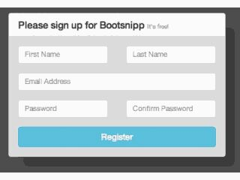

5.Create a Navigation bar (with dropdown) with CSS.In this exercise you will create a navigation bar. On completion, the page will look like following

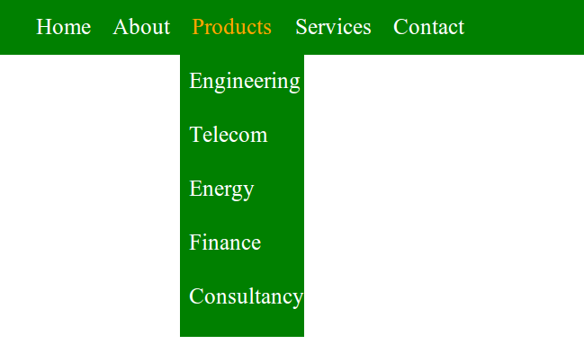 6.Create a CSS Grid In this exercise you will create a CSS based Grid. On completion, the page will look like following

