Fleet Shop Scheduling
By Joel Levitt
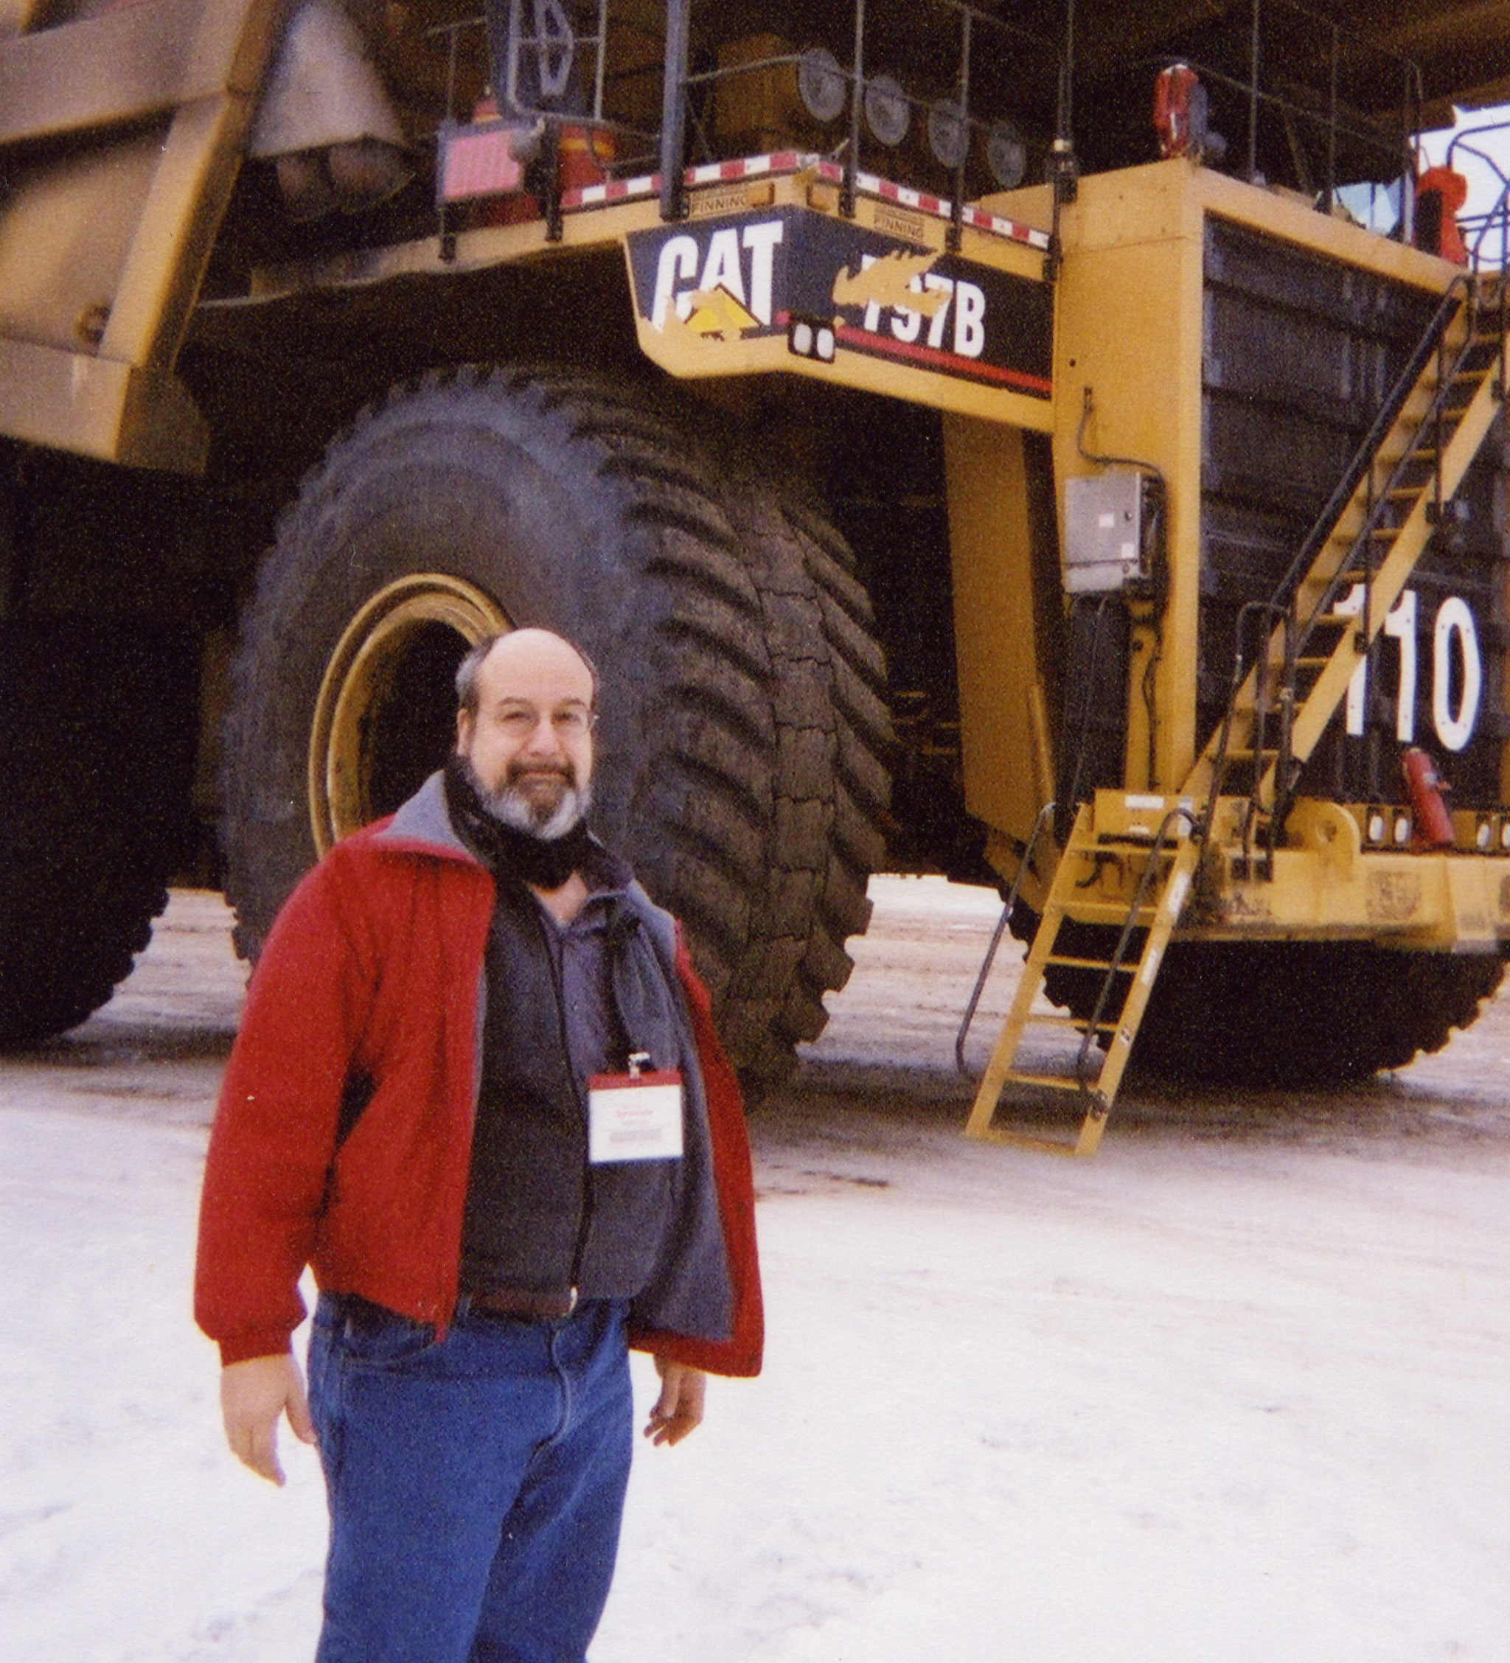
Every shop should have a technique to schedule each crew. In addition other work should be reviewed before work on a machine is started (such as PM’s that will come due in the very near future.
Shop scheduling tips
- The first items scheduled are the machines still in process. Use substantial effort to solve what ever problem is keeping them from being finished. Occasionally you can put a unit back on to work without all the work complete if the defect will not interfere with safe operation, quality or production level.
- Control your vacations with annual sign-up sheets. In one facility people signed up for vacation at the beginning of the year and then again a quarter at a time. The order was rotated so that everyone had a first choice. The number and skill sets of the people on vacation at any one time were regulated.
- Never start a job you can't finish (due to parts, tools or outside services). Identify, where possible all parts and other resources needed. Identifying resources is called job planning.
- Reserve parts by pulling them out of stock and putting them in a staging area (some places use plastic totes). One shop had a wall of old bus lockers. Parts were pulled and put into totes and slid into a locker. The key was put into a plastic envelope with the work order. Start the job when everything is there.
- Most of the schedule will come from PMs that are scheduled. They will constitute 10-15% of your work load and create an additional 45-55% from corrective items.
- Is there a day-of-week effect? If so then some of your demand is known by the day of the week. This is common where there is some activity over the weekend. On Monday morning a bunch of machines are broken.
- Overtime should be the result of a short term inequality between the demand for services and the resources then available. It should be known about well ahead of time. If there is an emergency requiring overtime then mechanics can work on routine work to fill-in the time, or finish the shift while waiting for the unit.
- Look outside; does the weather influence the schedule for that day?
- Limit yourself when assigning more then one person to any job unless absolutely necessary. Of course, safety sometimes dictates when two people must be used. Also you should never have only one person in the shop. Two or more people on a job slow the job down. Studies have shown that having 2 people on the jobs might make the likelihood of a safety incident higher than 1 person.
- Supervisor should show up randomly if they are responsible for off shift work.
- Rule: If possible machines that are started are worked on until they are completed.
- Keep overlap between shifts to a minimum. The supervisors should be overlapping and finding out where each job is and passing that on to the crew member. You can observe this- if you overlap do the mechanics actively go over the jobs or is it an extra break?
- Run in as few shifts as possible. Three shifts is tough to crew and to get productivity out of. Keep in mind the advantage of looking closely at doing maintenance when the units are NOT in demand (if production runs 16 hours maybe major maintenance can be done in the last 8.
Consider your demand hours
Demand hours are the hours that the machine is in use. This is important. If it is possible schedule the bulk of your maintenance activity should be scheduled when your machinery is not in demand. Ideally the day shift would concentrate on multi-day jobs and emergency work. The evening would focus on PM and corrective jobs. In some shops where the demand is during daytime and they are constrained to day time shop hours they have some mechanics come in very early to get some of the quicker jobs out of the way before the operators arrive.



