I have a dream
By Joel Levitt
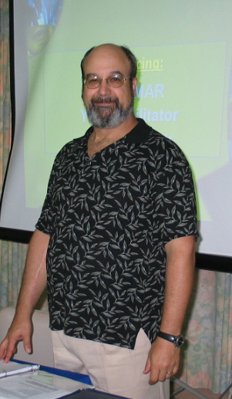
I have a dream. No not the dream of Martin Luther King about all people being created equal. My dream is about the organizations that we all work for. I dream that all organizations will act responsibly toward people and the environment. I dream about the day where there won’t be news stories about refinery explosions, OSHA fines, or other malfeasance. I dream of a world where companies have higher safety and environmental standards then the government requires.

In some ways my dream is being realized. Many of you read or heard about the Indian car company Tata and their promise to build a car for less than $2000. Well I was in India for a class on PM and PdM. There was an engineer from GM India. GM India is a bright spot in the GM Corporation with sales increases of about 37% year over year.

I asked the GM individual about the Tata plan for a cheap car. I asked if his company would go after that part of the market. He said he didn’t think so because GM’s global safety standards would preclude building a car in that price range. In other words GM’s safety standards are higher than required by Indian law. That’s my dream where organizations have standards and ethics (that they follow even if no one is looking) that exceed the local laws.

I don’t think anyone would deny humanity has gotten the world into a pickle. As maintenance professionals the question is what contributions can we make to do our part? The question is what is the contribution of maintenance to the world? That is a big and sometimes uncomfortable question.

Can better maintenance practices save the planet? Improving the maintenance practices worldwide is not enough, so probably not. But it is unforgivable and irresponsible for any group to not do its part. So, while we cannot solve the problems of global warming or resource depletion or any of the other problems ourselves, we will do our part. We can also provide leadership in our organizations for these changes.

Our part is to make our organizations more efficient in all measures. Every gallon of diesel, every breakdown, every part used even every unnecessary hour we spend wastes resources. While the goal of Lean Maintenance is to save money by cutting costs of operation, this is secondary to bigger game of making our companies and other organizations more responsible in how they conduct themselves.

Responsibility is using the fewest resources possible to get the product or service delivered. Responsible is to leave where ever your facility is better than how you found it. Responsible is to be good and protective toward your neighbors and employees. Responsibility is that you have standards and ethics that you follow even if no one is looking. Finally we want to be proud of how our organizations and leaders conduct themselves.

I have had the profound privilege over the last 25 years to work with maintenance individuals and their organizations that fight to do the right thing for their employees, customers, communities and the environment. When no one knows what they do but themselves, even in the middle of the night they do the right thing. Even when others in the company are yelling to cut corners these men and women take the heat and do the right thing. I want to thank you for all you’ve done that we will never know about.

Partially adapted from Joel Levitt’s new book Lean Maintenance to be published this spring by Industrial Press NY.

