The Internetworked Maintenance Department
By Joel Levitt
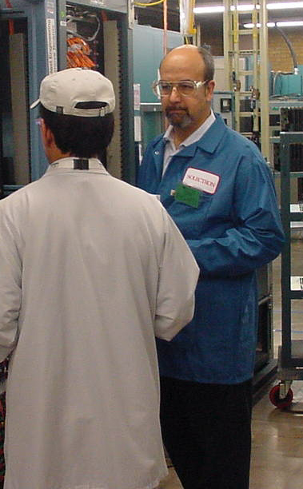
There is a conflict between time available and the lure of the Internet. The Internet promises great access to information, communications and computer programs. Most maintenance people are up to their belt in alligators and have no time to surf. Even if the company allowed us to go online (many still don’t) when would we find the time to track down all these alleged goodies?

In this article we will discuss how to develop a game plan that minimizes your time investment while still providing significant capabilities.

Need an Internet connection? Arguments to use with management:
Locate used machinery and save money and time
Locate new sources for parts and save money and time
Communicate more efficiently with existing vendors saving downtime and money
Get updates to shop software quickly and cheaply and save money and effort
Keep up to date with industry trends resulting in better decisions
Etc.

The techniques in this article will use some time management practices. The first practice is to make a list. Answer the question: what would you like to be able to do with the Internet? This will be tough to answer before you spend time online. If you are a newbie (someone new to the Internet) and don’t have a connection at home (and don’t want one yet) schedule yourself at a local library. Almost all libraries in the US are wired to the Internet. They also frequently have short orientation classes. Newbies, go and take one!

First assignment: Make a list of what you would like to get out of use of the Internet.

Times they are a changing
In unofficial surveys (I ask questions about Internet usage in all my maintenance management classes) double the maintenance professionals report Internet usage for some maintenance purpose from last year. In many cases the usage is from a home computer because the company would not give access or there was no time during the day. This trend was duplicated in classes in Asia and Canada. In fact, large companies in Asia seem to be moving faster toward the Internet because to them the maintenance supply chain is longer and more tenuous (more need to find quality vendors in US, Europe and Japan). Of course, E-mail is everywhere, and most maintenance departments use it.

How the best of the breed use the Internet. Pick some favorites.
For most of these exercises you will use your browser’s favorites or bookmark functions. Learn enough about that function to be able to organize the listings, add and rearrange folders. A friend or the companies’ IT department would undoubtedly be delighted to show you this. One tip is that the bookmark will read what ever the web programmer called the page (like CS12-Type 4 or whatever). When you create a bookmark or favorite you have the opportunity to name it what ever you want. Chose a name that means something to you!

When you are into both projects you might want to periodically revisit your list of what you want to get out of the Internet. Do you have any additions, corrections, or deletions?

The goal is to set up a short time every day (if possible) to work on the two projects below. Thirty minutes is ideal, even fifteen minutes is fine. Set a timer and stop when your allotted time is up.

After two weeks you will have developed a sense of what is available to you from your vendors. This project can be ongoing and you can interweave the second project on alternate days.

Equipment Project
- Bookmark the sites of all of your vendors. Try to do one vendor per period (day). Find the addresses (URL) from their literature or use a search engine. Look around and see if there are any resources that you can snatch or otherwise use. Things to look for are web based training on the equipment, announcements of recalls or fixes for problems, promotions (discounts on wear items or consumables), new distributors, and review the site for real technical data (drawings, O&M manuals, useful photos, etc).
  - Create a folder for the vendor.
  - Enter any resources you found into the vendor folder
  - If you hit a mother load you might make a sub folder such as training and put the URLs into the subfolder.
  - You might make a standard set of folders for all vendors of that type.
  - Be sure to add any E-mail addresses to your address book.
- Enter the model number exactly as it appears on the machine manual of your critical pieces of equipment into a search engine such as www.google.com Investigate the hit list returned for useful sites. Some you may find are used equipment dealers with that equipment, parts sources, and O&M manuals hidden in the companies’ site (that you couldn’t find going in from the home page).
  - For the machines you can always file the bookmark under the vendor file mentioned in the last section.
  - Another strategy is to create folders for the class or category of equipment such as milling machines, cold headers, etc.
  - Bookmark the used machinery dealers into the appropriate categories. Of course, you can file the same site into several folders.

Industry Project
Every industry has its space on or share of the Internet. Some industries like software have so much space that you couldn’t review what’s out there today in a century, even if nothing is added. Other industries have a more modest presence. The key is to find the super sites for your industry. Super sites have hundreds of links in one industry or area. From these super sites you can find almost anything you want to know about an industry.

How to find super sites
- Start with trade journals that you read. These are usually super sites because they offer links to advertisers, authors and associations. Find a trade journal and spend a session looking around, reading articles, visiting advertisers, and following links. If you like this, cancel your subscription and put an entry in your day planner every month to visit the site.
- The second place to look is the trade associations. Many of these associations are super sites with useful links throughout the industry.
- The hard way is to enter your industry into a search engine and follow-up any of the leads that look good. This is the hard way because you have to do the legwork. As you find useful sites bookmark them. Someday you might want to create a private super site so others don’t have to. In the maintenance field visit www.maintrainer.com and push the resources button.

Working a few minutes a day on these projects will propel you into the forefront of companies that are using the Internet. As you investigate the Internet in a structured way you will run across other useful sites. Be sure to bookmark what you find.

In fact, you might never really finish the two projects. In a month you will have a valuable resource and a conviction about the importance of a small ongoing investment in the Internet.
