Pre-Seminar Questions: Answer Y or N or give a percent answer:
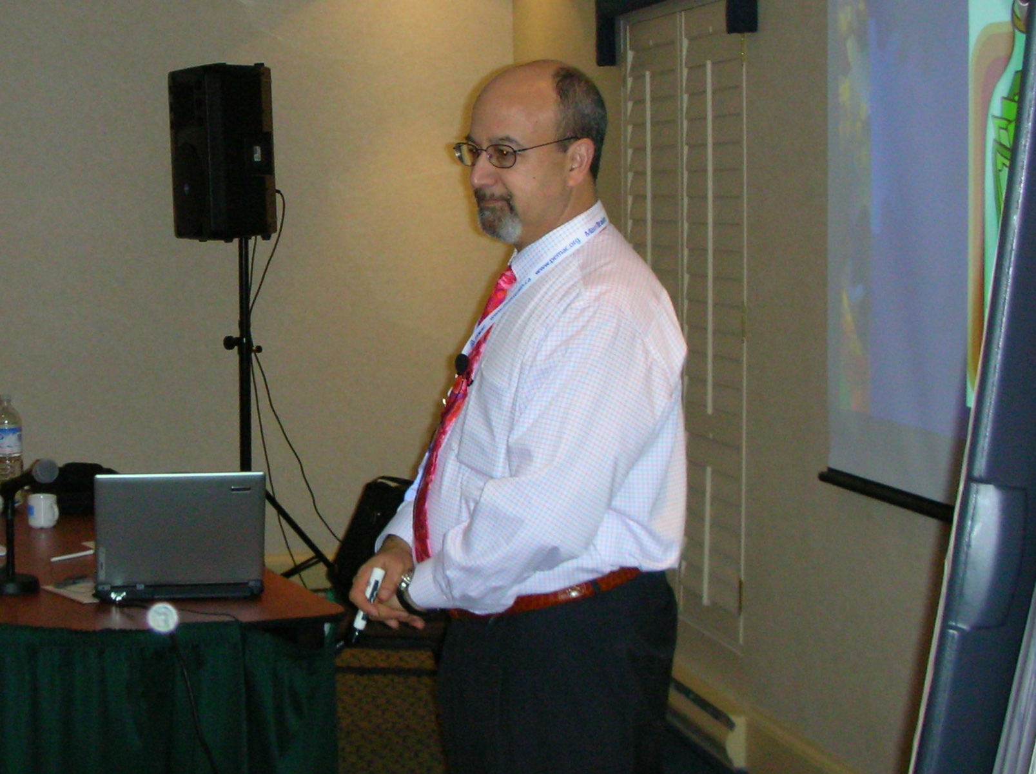
By Joel Levitt
___1. Is the maintenance department leadership part of the top level strategic planning for the future of the facility, product or organization? Are maintenance managers taken seriously?
___2. Is there an absolute commitment on a long term basis to improve the quality and reduce the cost of maintenance among top management and are funds available for investment?
___3. Is there a five or ten year strategic maintenance plan including projected capital replacements which is reviewed and updated annually by both maintenance, operations, and top managers?
___4. Are there regular meetings between users and maintenance to set priorities?
___5. Do repeated or expensive failures automatically triggering an investigation to find the root cause and correct it?
___6. Are maintenance jobs routinely completed on time, on budget, as planned?
___7. Is 1-5% of a technicians' direct hours spent in craft, multi- craft or other related training?
___8. Are drawings and specifications on all new machines, processes and buildings reviewed by the maintenance department early enough in the process so that improvements can be made without adverse impact to the whole project?
If you have a CMMS (Computerized Maintenance Management System, next 3 q's):
___9. Do you think that maintenance workers and supervisors have the training, knowledge, positive attitude and access into the CMMS (Computerized Maintenance Information System) to investigate a problem?
___10. Is garbage and faked data kept out of the CMMS
___11. Is the data coming out of the CMMS commonly held by both you and the workers to be accurate and useful?

BONUS QUESTION:
___12. What is your overall rating of your maintenance department?

