Planning Maintenance Activity for Turbo Machinery

Turbo machinery is complex and expensive to maintain. Good maintenance practice is essential to get the full service life out of the equipment. Turbo machinery mechanics and electricians are among the most skilled maintenance workers in the world. With all the skills and all the money we spend on spares and training why does maintenance activity run smoothly in some facilities and not others? Why do some facilities run with smaller crews than yours without ill effects? Finally why do good people leave your company to work for other companies and report that the environment is better? The answer to all these questions might concern your maintenance planning and scheduling (or lack of it).

In the simplest form, planning maintenance activity is stepping through all the steps to perform that activity on paper (or on screen). Visualize changing the main bearings. While doing that identify (ahead of time) all the resources needed to perform that activity. Resources include everything needed to do the job including labor, spares, lifting equipment, in short everything! Since some of the spares are under extremely long lead times advanced planning and pre-ordering is essential in our field.

Planning is just identifying the resources needed for each step. Scheduling maintenance activity is putting time the job into the calendar. All the resources (everything such as cranes, spares, labor converges at the given time and place. We need 50T crane, 4 pipe fitters and 600’ of 6” pipe, at unit 7 on Wednesday at 4:00 pm, etc).

Why does maintenance run better with planning? Why is a planned atmosphere better to work in? The first fact is that in an unplanned maintenance environment maintenance workers spend a lot of their time spinning their wheels. For example a typical maintenance worker can only do maintenance work 35% of their day:

 | Reactive without planning and scheduling
Receiving Instructions | 5%
Obtaining tools and materials | 12%
Travel to and from job (both with and without tools and materials) | 15%
Coordination delays | 8%
Idle at job site | 5%
Late starts and early quits | 5%
Authorized breaks and relief | 10%
Excess personal time (extra breaks, phone calls, smoke breaks, slow return from lunch and breaks, etc) | 5%
Subtotal | 65%
Direct actual work accomplished (as a percentage of the whole day) | 35%

These percentages were based on surveys done at heavy industrialized plants in the US and may be different from the levels of productivity in any individual plant. The low level of actual maintenance work is very frustrating for many of the top maintenance workers. The inability to exercise one’s craft and feel the satisfaction of a job well done makes people seek other employment.

The cause of the low productivity cannot be attributed to the workers (it is common to blame the workers). In fact, almost every loss of productivity can be traced back to some well meaning management decision.

These percentages can be easily converted to minutes. In a 480 minute day in a typical heavy maintenance situation such as a Liquefied Natural Gas compressor station a typical maintenance worker will spend
 | Reactive without planning and scheduling
Receiving Instructions | 24 minutes
Obtaining tools and materials | 57 minutes
Travel to and from job (both with and without tools and materials) | 72 minutes
Coordination delays | 38 minutes
Idle at job site | 24 minutes
Late starts and early quits | 24 minutes
Authorized breaks and relief | 48 minutes
Excess personal time (extra breaks, phone calls, smoke breaks, slow return from lunch and breaks, etc) | 24 minutes
Subtotal of what we call non-productive and marginally productive | 312 minutes non productive
Direct actual work accomplished (as a percentage of the whole day) | 168 minutes working

How could we save time by improving the preparation for jobs? One factor is preplanning and arranging that the resources show up when the job is starting to execute dramatically reduces the stopping and starting typical on unplanned maintenance jobs.

Typical unplanned job where every resource has to be determined then obtained.

Small maintenance jobs and service work are the least productive because the ratio of productive to non-productive time is the least favorable. Even in the worst maintenance situations the more the maintenance job looks like construction (replacing 400’ of pipe line) the more productive the workers generally are.

Most industrial maintenance departments will plan large jobs (even if the planning is done by the maintenance worker just before the job starts.) Almost all maintenance departments will plan shutdowns because of the large negative impact on revenue of having the plant out of service.

In a Planned maintenance job the resources are obtained at the beginning and the job is executed without interruption (when everything goes well).

Keep in mind that in all likelihood your best workers already work like this even if they are using a scrap of cardboard and a stubby pencil to plan their jobs! The planning effort is to make the average and lower workers work at this level.

One informal rule of thumb is that each dollar invested in planning typically saves three to five dollars during work execution and the duration of a planned job is commonly only half as long as that of an unplanned job.

When we add effective scheduling and pre=planning for jobs the situation changes considerably

 |  | Proactive with planning and scheduling
Receiving Instructions | 14.4 minutes | 3%
Obtaining tools and materials | 24 Minutes | 5%
Travel to and from job (both with and without tools and materials) | 48 minutes | 10%
Coordination delays | 14.4 minutes | 3%
Idle at job site | 9.6 minutes | 2%
Late starts and early quits | 4.8 minutes | 1%
Authorized breaks and relief | 48 minutes | 10%
Excess personal time (extra breaks, phone calls, smoke breaks, slow return from lunch and breaks, etc) | 4.8 minutes | 1%
Subtotal of what we call non-productive and marginally productive | 168 minutes non-productive | 35%
Direct actual work accomplished (as a percentage of the whole day) | 312 minutes productive | 65%

Certain categories change dramatically with a logical explanation and other categories change without a logical explanation. For example, receiving instructions goes down because the planned job packages answers most questions. Obtaining tools and materials drops because the warehouse can anticipate the demand and pre-pick the parts or at least insure that they are in-stock.

Other categories are not so simple. In a planned environment excess personal time drops by a factor of 5! Even the time lost to late starts and early quits drops. Apparently workers in planned environments don’t like to take extra time off or come to work late or leave early as often.

Job Planning: Steps of the Job Planning Process
How do you go about planning maintenance activity?
A need has been shown through a work request, work order or notification. The need can come from operations, from a maintenance inspector, even from the computer system itself (in the form of a PM ticket).
An Inquiry has asked whether the job should be done, what its priority should be and if a related job is already in the backlog. All jobs should be looked at to see if they should be done. There should be a cogent business reason for every maintenance job and the job shouldn’t be a duplicate of another job.
The planner should be on the shop floor as often as necessary to visit jobs. A visit to the job site and a discussion with the requestor might be the first step after determining that the job should be done. Half the battle is pinning down exactly what is to be done (scope of work).
Has the job or a substantially similar job has been done before? If the job has been done before then it should be in the planner’s library. The old job plan might be identical or just need minimal modification to suit the new need.
Get approval if necessary based on an estimate of costs. This defining “how much” it will cost and obtain whatever authorizations will be required. For routine most maintenance work of replacing deteriorated parts the level of authorization should be pretty minimal. Project work or shutdowns should require higher levels of approval.
Thorough analysis has been used to break the job down to its component tasks. List the job steps, defining “what” is to be done. Take the physical location and spaces around the equipment into consideration. This defines “how” the job will be performed.
Evaluate each step for hazards and risk. This adds safety to the how. Risk evaluates how the job can impact the whole company or whole department or individual work crew if it goes bad.
Include ideas about whom and how many people can work efficiently in the space. Establish duration and work force needs required to perform the work. Determine the skill sets needed, and any special licensing requirements. Clarify the sequence of skills required throughout job performance.
Next, identify what’s needed in terms of all spare parts, materials, consumables, special tools, PPE (personal protective equipment) and equipment necessary to do the job. Consider the movement of materials into and out of the area. Determine if you have the items in stock.
Then, determine what knowledge is needed via essential reference materials. This includes drawings, wiring diagrams and other Reference Documents
Finally, planning is not completed until you list everyone who needs to know what is going to happen. Communication Planning is essential.
The last step moves you out of planning and into coordination and scheduling. Coordinate with the asset custodian to select a mutual time when maintenance can have the resources available and operations can release the asset. Schedule the work; thus defining “when” the job will be performed
List all permits and clearances. These Safety and legal permissions should be thought through and provided for
All parties that should be notified are listed and all processes that have to be rerouted, shut down, or backed-up are identified.
Preparatory and Restart Activities are listed and coordinated (regardless of whether the responsibility for implementation belongs to operations or maintenance).
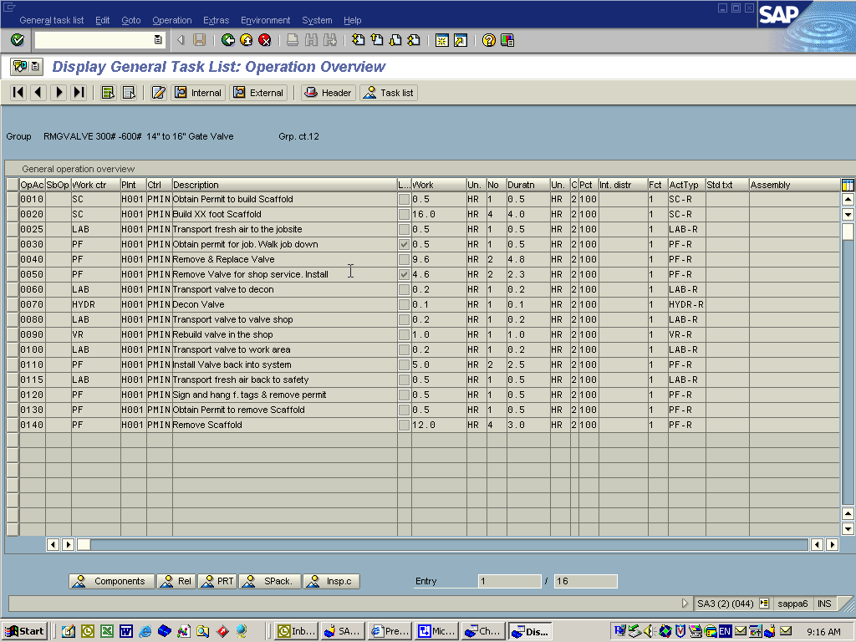
Typical planned job in the computer system (in this case SAP)

Scheduling
Planning identifies all the resources needed to do the job. Nothing has been moved or ordered in the real world until the job is scheduled. Once it is scheduled (and only when it is scheduled) do we start to move the players and materials.
In the Turbo machinery field the lead time of key parts is extremely long. In most cases the responsible planner will plan the job and immediately order the material. In that case the planning and scheduling is combined into one activity. Even in that case the labor and lifting gear will not be arranged until the job is scheduled. Of course, the schedule is going to be determined by the delivery date of the critical spares.

The scope of Scheduling includes:
Scheduling is bringing together in precise timing the six elements of a successful maintenance job (FROM THE JOB PLAN): labor; tools, materials, parts and supplies; information, engineering data and reference drawings; custody of the unit being serviced; and the authorizations, permits, and statutory permissions.
Scheduling requires a balance between the work expected next week and the resources available next week. The process of matching next week’s demand for service with resources available after accounting for all categories of leave, training, standing meetings, and indirect commitments, plus consideration of individual skills is called creating a work program.
Prepare a “Weekly Schedule” that represents the agreed upon list of work (agreed with operations) to be accomplished with available resources. The schedule also assures that all preventive and predictive routines will be accomplished within established time limits.
The scheduling process includes the consideration of alternative strategies: Where the schedule assigns specific jobs to specific people (allowing second-string players into the game to gain experience … as feasible.
Where possible problems are considered and accounted for.
Of course ensure that responsible supervisors receive and understand the planned job packages for scheduled jobs.
Simple things
In many cases it is the simple things that will make a difference. Planning is identifying all the things that make up the successful job. Most of the things that hold jobs up and reduce productivity on a daily basis are simple things missed. Scheduling makes sure the simple things that were identified are available when and where needed. The result is higher productivity, more satisfied workers and better profit for our companies. Thank you for reading. Joel Levitt

Joel Levitt is a long time Consultant and Trainer in the area of Maintenance Management. He works with major organizations world wide and can be reached at JDL@Maintrainer.com
You can sign up for his free newsletter The Maintenance Manager’s Newsletter at www.Maintrainer.com

