Put the People into PM

By Joel Levitt
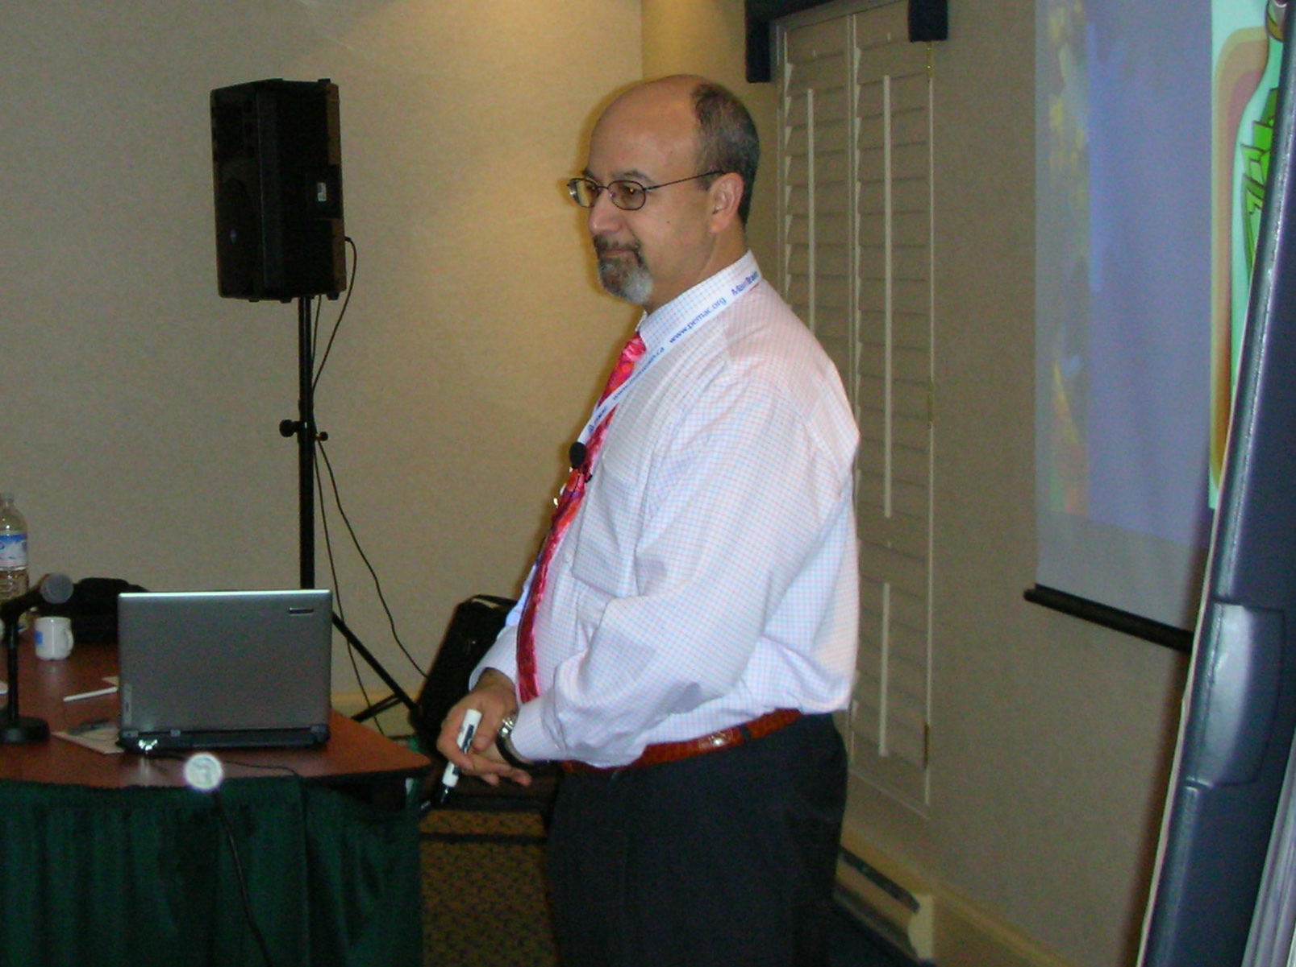
Did you ever think about what kind of people you want doing PMs on your equipment? Most maintenance managers don’t give PM a second thought (except to find the time to complete the work). In fact having the right kind of people in the PM loop can make a real difference.

You’ll laugh and say it would never happen in your shop but this really happened to me:

Automobile mechanic does a PM to a 2-month old car on a service request that the car would stall. The stalling problem was presumed to have been handled. In fact no one else had looked at this vehicle.

The mechanic cleaned the terminals of the battery (which was a task in this PM routine). He didn’t notice that the battery hold down was gone. The battery had shifted in the holder so that the + terminal had shorted against the chassis. The shorted battery boiled over and spilled acid on the wiring harness. This caused the harness insulation to be degraded to the point that exposed copper could be seen.

If the owner hit a bump the harness would shift and the car would stall. It takes something to miss all that damage. The service writer was in shock when shown what was passed as complete.

What went wrong here? Besides the communication problem that the problem had not been handled, the PM person was asleep at the wheel! Have you ever done PM for 8 hours? PM is pretty tough work, maybe the toughest in your shop.

Here’s what I look for in a PM person. Six Attributes of a Great PM Inspector:

1. Can work alone without close supervision. . They might be given a packet of PM tickets and disappear for a couple of days. The inspector has to be reliable since it is hard to verify that the work was done This being reliable has to be built-in because it is quite hard to add this attribute afterwards.

2. The inspector should also be the type of person who will fill out and complete the paperwork. The paperwork and subsequent write-ups for additional work need to be complete and accurate. The data is crucial to long term analysis and optimization of the effort.

3. The PM inspector should know how to (and want to) review the unit history and the class history to see specific problems for that unit and for that class. Some times knowing about the last problems with that unit will indicate an area of weakness in the design, a great inspector will take an extra look where there have been problems in the past.

4. A mechanic is re-active in style. A PM inspector is pro-active in style. In other words, the inspector must be able to act on a prediction rather than react to a situation. He/she is primarily a diagnostician, not necessarily a `fixer.'

5. Because of the nature of the critical wear point the more competent the inspector, the earlier the deficiency will be detected. The early detection of the problem will allow more time to plan, order materials, and will help prevent core damage.

6. PM inspectors should not be interrupted, and be segregated (while they are in the PM role). PM is a mental process and needs extensive concentration.

Games People Play- getting the PMs done as designed

One of the toughest problems to solve is how to insure that the inspector is actually doing the inspection on the task list. Horror stories about maintenance catastrophes frequently feature task lists that were signed as completed but obviously not performed. The consequences of a PM not being done on a truck pulling even the most innocuous load could be deadly.

For most people PM tasks are boring and mind numbing. The challenge of leadership is to inspire the people in PM roles to want to do the tasks well. The inspector mentioned below (or for that matter mentioned anywhere in this section) can be a regular mechanic, operator or helper (if appropriate) on a part time basis or a full time PM technician.

1. Does the inspector know how the PM activity fits in to the overall scheme? Is it well known that PM impacts reliability, safety, costs and output? You see the inspectors in nuclear power plants or in airlines knowing full well the impact of missing a PM (and even then it happens).

2. Drag your top management down to the shop and have them address the maintenance crews about the criticality of PM and safety, on-time delivery or what ever. You might have to write the speech. People attend to what they think management thinks is important. Let them hear it from the horse's mouth.

3. Present the job as important. If people feel that PM is stupid, boring and low priority fill-in work they are less likely to put themselves out.

4. One of the most important things you can do to insure the work is done is to let your PM mechanics themselves design the system and tasks themselves.

5. One hole is lack of specific skills. An individual might be lacking a specific item of skill or knowledge to effectively perform the task. Be explicitly sure the PM people are fully trained. Keep them going to school to learn the latest of the latest.

6. Improve the relationship between the mechanic and the driver. Instruct the mechanic to make personal contact. Some PM task lists include a task "talk to operator and determine if equipment, has operated normally since the last visit." If there is not a task like this add one!

7. Make it easy to do tasks. Where you can re-engineer equipment to simplify the tasks and route the people to minimize travel.

8. Simplify paperwork.

9. Improve accountability by mounting a sign-in sheet inside the door to the equipment. Be sure the people who do the tasks sign a form and are included in discussions about the equipment. When people know they might be quizzed about an asset they are more likely to complete their PM tasks. When people know that after a breakdown an inquiry is conducted and the PM sheets are reviewed it motivates them to complete their tasks.

10. Make PM a game. One supervisor got a small amount of money and went to the local fast food restaurant and bought $.50 gift certificates. Each week he hid 8, 3X5 cards (that said "see me") inside equipment on the PM list. He traded the cards for the certificates. He knew when a card wasn't found (PM wasn't done). His comment was "What people would do for $.50 they wouldn't do for $27.50 per hour!"

11. PM professionals like new, better toys (sorry better tools not toys). Technology has opened up the field for sophisticated relatively low cost PM tools. They might include $700 for a pen sized vibration monitor, $500 for a cigarette pack sized infrared scanner, or $1500 for an ultrasonic detection headset and transducer. If appropriate to the size and type of equipment, these tools will motivate the troops and increase the probability that they will detect deterioration before failure.

12. In any repetitive job boredom sets in. Consider job rotation, reassignment, project work, office work like planning, design, and analysis to improve morale.
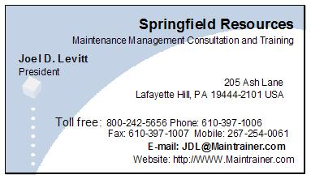
In short do what you can to make the important PM job work for you!

