Quick Fleet Maintenance Audit

By Joel Levitt
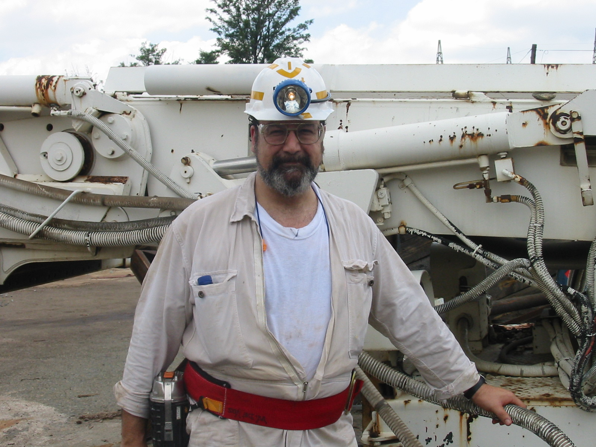
I’ve been working on a new course. One of the elements of this new course is the ability to look at your own shop with an outsider’s eyes and see what is really there. To direct your eyes I’ve designed a series of questions, physical checks and routines that are designed to uncover what is really going on (below the surface of those glowing reports)

Your assignment is to perform the audit and see what you find out. If you are brave send me your findings and I might comment in a future column.

Also you fleet experts (particularly those of you whose experience put me to shame) what questions have I missed?

Fleet Audit (to be conducted right now and annually thereafter)

Priority | Q# | Question | Findings |  | Grade
 | 1 | 10 random repair orders are reviewed for completeness and accuracy
 | 2 | Driver reports are reviewed and corrective work is done in a timely manner. Check 10 random reports.
 | 3 | Written RO in evidence for all except genuine emergency repairs. Check this right now for all bays.
 | 4 | Flat rates (standards of some kind) for all recurring jobs written on RO. Check all RO open on shop floor now.
 | 5 | Check to see if 1 day's work planned for each mechanic at least 1/2 day in advance.
 | 6 | Is the Maintenance Schedule visible to all mechanics
 | 7 | Check fluid levels and batteries on 10 random vehicles.
 | 8 | Pull 10 PM sheets and verify that they are complete and correct. Track any Corrective items and verify a RO was closed on each corrective item in a reasonable time.
 | 9 | Building is clean including floors, walls, eating areas, lavatories, and lighting fixtures (adequate light).
 | 10 | Outside yard is free from debris, oil, diesel and metal objects (nuts, both, nails, small parts).
 | 11 | There is a logic to where vehicles are parked in the yard. Look and see if you can see it.
 | 12 | Maintenance office is clean and straightened up(consistent with use).
 | 13 | Trash cans through out shop are less than ½ full
 | 14 | Work benches clean, area around benches clear. No trip hazards
 | 15 | Common tools are located in or near each bay where they are used (and there are enough of them) such as oil drain pans, jack stands, air tools
 | 16 | Each bay has retractable air hoses at both ends.
 | 17 | Each bay where PM is done has an overhead dispenser for motor oil
 | 18 | Less frequently used tools are stored on shadow boards or other way that is easy to get to and easy to inventory.
 | 19 | Fire extinguishers (dates), electrical cords condition, other safety or fire
 | 20 | Oil storage, waste oil areas and pits are clean and minimal spillage.
 | 21 | All large tools are operable. Compressors, tire machines, brake lathes cleaned and serviced regularly
 | 22 | Broken parts are segregated for inspection by supervisor or senior mechanic.
 | 23 | Check 10 vehicles are they clean inside and out consistent with use
 | 24 | Check tire pressure, alignment, size on duals. How many units are within +5% of rating
 | 25 | Perform PM on a random unit. What did you find?
 | 26 | Adequate space, storage, lighting
 | 27 | As you look at the stock room area is it clean and in order visually?
 | 28 | Places for incoming and outgoing rebuilds. Are all rebuildables properly tagged?
 | 29 | Are all part storage positions clearly labeled? Check 10 random how many are correct?
 | 30 | All tires are tagged and the tags are correct. Check 10 random tires for good tags.



