Save them from themselves
By Joel Levitt
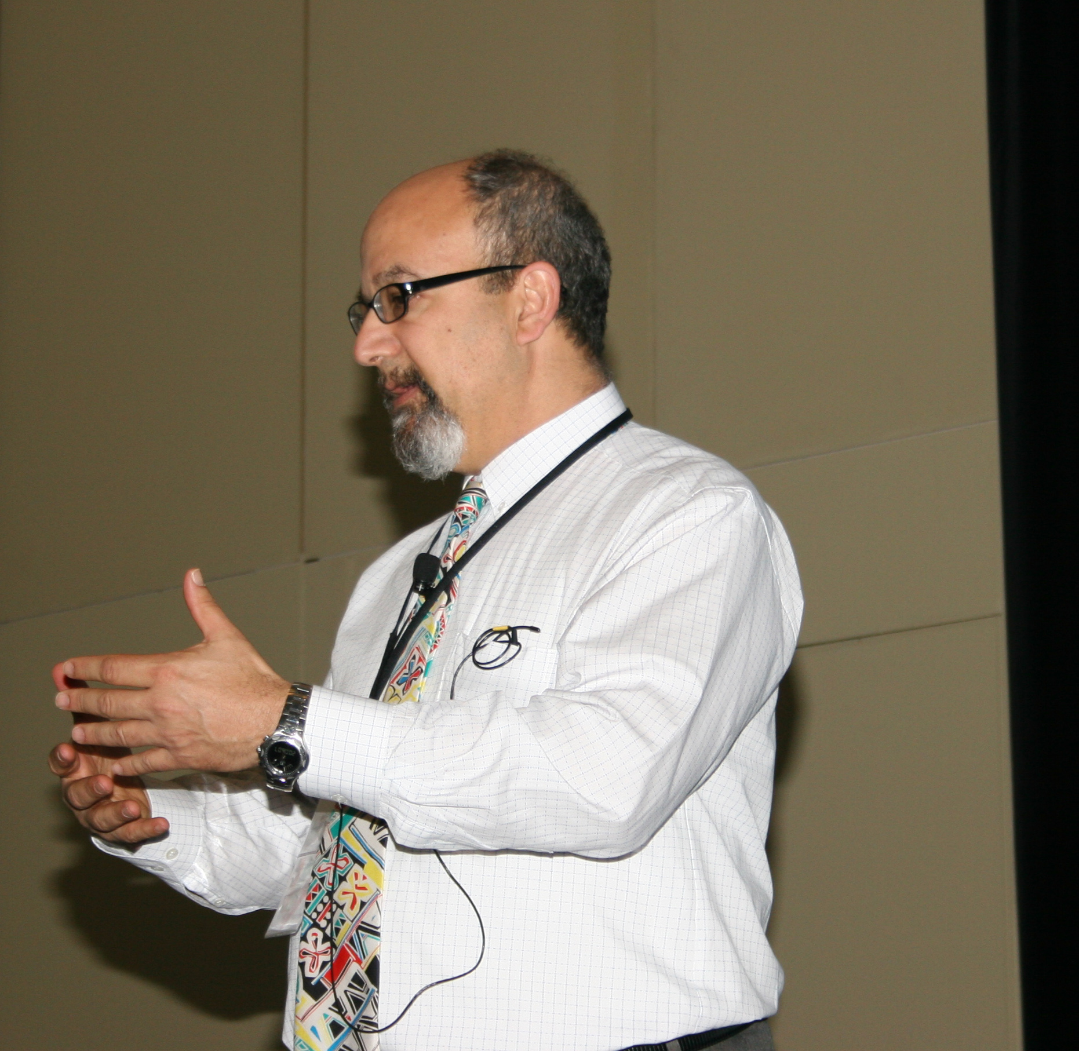
I had a physical before the holidays and my Doctor told me to lose weight. We have a great relationship. I trust him and admire his expertise, particularly about the risk factors for sickness. Oh, also I do really want to live a healthy life.

I think about that when (now that the holidays are over) I tasted all the desserts at the Christmas party. I was brought up to be polite. I mean isn’t it polite to try everything. Isn’t it a matter of good manners? Ok so there were 11 desserts. Ok so some of the tastes were somewhat larger than necessary.

Rewind the tape a few months. I was visiting a mine that operated haul trucks, shovels and a variety of other heavy construction pieces. (I spoke about them indirectly in a salute to heavy equipment manufacturers in a previous column).

Their complaint was that in spite of significant PM effort they were still suffering from breakdowns. How could this be so? The usual suspects are pencil whipping the inspection records, incompetent PM inspection, improper focus (not looking at the critical wear areas), too long between intervals, bad operation and cowboy operators.

What I found was that the inspectors were doing their job and finding the deficiencies (as far as I could see). They were writing up the deficiencies properly as corrective repair orders. Each unit had a nice fat file of corrective repair orders. The operators were mostly professional long timers and didn’t seem to be abusing the equipment.

What was missing was a surprise. It was the commitment to do the corrective items before breakdown. Systems reported as deficient in the corrective repair order file were not being addresses and those same systems were breaking down.

Maintenance had to make emergency repairs, air freight parts, have forced overtime and feel generally stressed. The measure was how many hours the equipment “was in the dirt.” For some units all that was keeping the unit “in the dirt” was baling wire and welding rod.

So in short we would do an all-day PM on a haul truck and write up a bunch of problem areas. The truck would go back on the line. It would breakdown a month later from an item on the corrective list. In fact the trucks were slowly getting harder and harder to fix because there are band aids on top of the band aides!

I asked both the maintenance manager and the operations (production) manager about that.
Maintenance manager: “Yea, they won’t give me the trucks to fix them only for the PM and when they break down. I don’t know how much longer we can piece together this equipment and keep it in the dirt.”
Operations manager: “We have a certain tonnage to make and the last time I gave maintenance a haul truck for repairs they kept it for 3 weeks. I couldn’t make the tonnage without that truck.”
There are many consequences to this behavior (actually not all of them are bad). For one you can have all the dessert you want (“trucks in the dirt”)! On the other hand break downs that do occur tend to be large, expensive and invasive.

So the Doctor told me to lose weight because he saw potential bad outcomes if I continued along the line I was. He was, in fact trying to save me from myself!

I wonder how many maintenance professionals feel like the Doctor who tells patients all day long lose weight, stop smoking or get exercise. Other people in the company have excuses, rationalizations and probably good reasons for ignoring the advice just like I do.



