Using Technology to enable improvements
By Joel Levitt
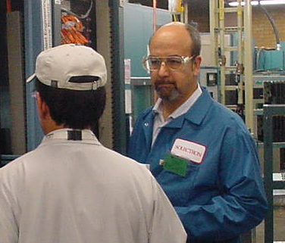
Technology will be one of the areas that help create breakthroughs in maintenance organization structure. Traditionally, maintenance was organized centrally to avoid duplication of support staff, balance out skill deficiencies and to improve command and control of the whole effort. Advances in technology will make the whole centralized/decentralized argument moot.

Consider a school district in Florida that covers 70 square miles. Originally all skilled craftspeople went to work at the central maintenance facility each morning. They picked up their work assignments and went to the individual school. They worked until completion then went back to the central facility (unless they couldn't finish, in which case they went directly back to the school the next day after authorization from their craft supervisor).

In many cases the mechanic left the school with the job completed and was sent back to a nearby school (or the same school, even) for a just breaking incident that started after the phone call. Up to two hours a day and more was spent in valueless travel.

Their first intervention was to divide the department into teams by geographical area and skill set. This way the teams were closer to their customers both physically and eventually, emotionally. The problem they created was duplicated support staff and overhead, spot shortages of certain skills, and no ability to get a hold of the whole group because there now was a new layer of management.

Technology can allow the department to run with the advantages of both the centralized and decentralized modes. The technology is as simple as fax machines in each mechanic's home, cellular phones in all vans, and home Internet E-mail hook-ups for all mechanics. Training and set-up would be provided by Information Services. Phone lines, cellular phones, fax machines, terminals and service provider costs were under $20/mo per person. Consider how you could design a response system with the technology (the possibilities are numerous, design for your individual situation).

Where possible, the mechanics were assigned to schools near where they lived. In any case they serviced the same schools where there were no major problems elsewhere. In the new model the central station dispatchers would show up at 5am to sort through the entire backlog. They would assign the jobs and fax the work orders directly to the houses of the assigned mechanics by 6am. Since the dispatchers were in closer contact with the mechanics they could more accurately predict when service was to be completed.

Perhaps there was an alternate design with a team of mechanics responsible for a group of schools. The team would elect a point person to coordinate contact with the principals. They would sort through all of the E-mail and assign by forwarding service requests to the mail boxes of the closest team member with the requisite skill set. Completed jobs would be posted to central for adding to the database as well as to the point person.

The mechanics would go to the school and complete the service with the parts and materials on their truck. If they needed materials they went to designated distributors and charged the parts to a blanket order pre-negotiated by purchasing. They communicated completed jobs back to dispatch by the school's fax machine.

After completing the job they would get their next assignment by the school's fax machine. Unless there was a shortage of their skill set or a relief situation they would stay in their home region. The cellular phone would be used to change the next job with instructions to report to a different school and pick-up the work order at the designated fax machine.

Management used E-mail to keep the entire crew up to date with policy memos, training opportunities, job information, weather projections and campaigns. Principals also used E-mail to directly talk to their assigned maintenance mechanic. On a monthly basis there was an all hands meeting to exchange information.

