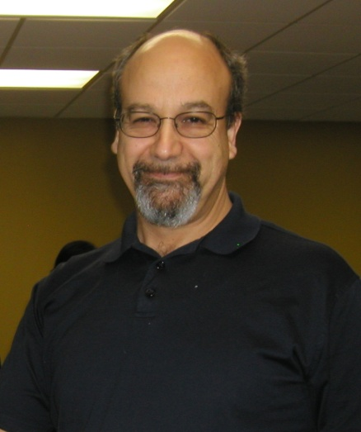**What are you proud of?**

This might seem like a funny question to ask. I think it gets to the core of why maintenance folks are the way we are and why we sometimes have trouble expressing how our contribution impacts the organizations where we work.

I attended a workshop conducted by Landmark Education. They are a global training company dedicated to training people to be more effective and get more out of their jobs and lives. The leader, Shirley Brown, posed some questions that I thought were pretty interesting.

by Joel Levitt, President Springfield Resources

One of the underlying ideas of this particular training is that who you are in the world is reflective of who is around you and the conversations you have with them and that they have with each other.

This idea of who you are being influenced by the people and conversations around you has been supported by studies of criminals. If you want a prisoner to succeed on the outside you have to help him find a new group of friends that have difference conversations (like about jobs, bills, 401K’s, and kids or family). The old friends just talk about crime and that’s what got him into trouble in the first place.

It is not only criminals whose self image is defined by our close circle of people. Think about drivers, mechanics or doctors, teachers or others. You could say they are what they are because of the immersion into those specific conversations of that work or lifestyle. Would a lawyer think of themselves as lawyers if they didn’t discuss laws and contracts every day.

Getting back to the course and question, it becomes clear that the way to change is almost simple – change by changing your conversations within your circle -just start to talk about something different! That sounds crazy. But it is something to think about.

The question she posed is “what are you proud of in your community?” This question can be asked about any of your communities (local community, church, friends, family, etc.).

The question got me thinking about my maintenance leadership community. This is a group of regular (mostly) guys who, when given a problem, act in a really extraordinary way. They are the ones that run toward a catastrophe. They are the ones who sacrifice their family lives to keep machinery running or get it running. They are the ones who seem to never give up even as the condition of the equipment deteriorates and are not given adequate money to repair it. Boy, do maintenance folks like problems.

If you excuse the metaphor giving a maintenance guy a problem is like giving your dog a bone. He will either eat the bone right away (solve the problem right away) or bury it in the back yard. The buried bone are dug up later to be worked on. The dog never gives up on the bone because it is too big or too hard. Neither does the maintenance fellow give up because it is too big or too tough. They may take a break from a problem but it can be dug up at any time because it is always there.

I’m proud of this community for that and for the fact that they do this because of an internal compass rather than external rewards, pats on the back or even the knowledge that they are being heroes. Like police or emergency room personnel maintenance professionals see the broken side of life. I’m proud to be part of the community that looks at the broken side of life right in the eye and can keep a good attitude.

I’m proud of a community that responds to people’s misfortune from the simple like who is there with jumper cables when a car doesn’t start to the profound like who is on the front lines after an emergency or catastrophe.

This community takes it on the chin for the sins of others. Who stays late when the machine, just bought, doesn’t work, or when there is no money who keeps the fleet rolling?

Ask this question about what are you proud of to your different communities and then listen to the answers. It might be pretty interesting. All the best Joel Levitt

