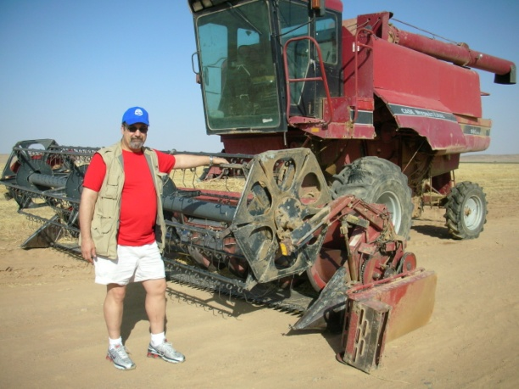**Program At SABIC: Safety and Reliability**

By Joel Levitt ©2011 [JDL@Maintrainer.com](mailto:JDL@Maintrainer.com)

In the US in 2009 there were 4,340 deaths across all industries, compared with 5,214 in 2008. That is a 17% fall in fatalities. Unfortunately the cause for the fall seems to higher levels of unemployment.

The injuries suffered by US workers are even more startling:

Accidents are common in farming and are particularly dangerous because an injured worker might be alone with no one to get help. Tadco farm in Saudi Arabia

**Nonfatal injuries and illnesses in 2009**

Total recordable cases: 3,277,700

Cases involving days away from work: 965,000

Cases involving sprains, strains, tears: 379,340

Cases involving injuries to the back: 195,150

Cases involving falls: 212,760

Think of it, if we fix some of the root causes of the fatalities or injuries we will be addressing the causes of both. There are many reasons for these injuries and fatalities. Some of the common ones include traffic accidents, falls, and a whole host of fatalities from maintenance work.

I want to discuss the maintenance oriented fatalities. Some examples of fatal accidents from OSHA records for last year:

Worker who was attempting to jump start a farm tractor, suffered massive trauma to upper torso when pinned between tractor and vehicle.

Worker died while performing hot work on top of a 10,000-gallon chemical storage tank that exploded.

While changing and wiring two heaters, worker turned on electricity to check wiring.  He forgot to turn off the electricity and was electrocuted by 480 volts upon contact.

Worker suffered fatal injuries after getting pinned up under conveyor while doing maintenance work.

Why did these people die? The answer to that question entirely depends on how deeply you want to delve into the causes. On first glance there are a lot of reasons with no commonality. Some of these accidents are the result of unsafe acts (hot work on a tank with an explosive mixture inside resulting in an unexpected release of energy), failing to follow procedures (not re-locking out the electric after testing), or bad judgment or errors in perception (getting pinned under the conveyor). Of course most accidents like these have several causes at the same time.

We could take another cut at incidents to get to see more causes. The technique that is commonly used is to ask “Why did this happen”. Called the “5 Why” technique, you keep asking why 5 times. That will get you pretty deep into the roots of the problem. In this case the question I would ask is “Why was the person in harm’s way in the first place?” The beauty of this technique is that answering “Why” takes you deeper into the incident and is simple enough that it can be done by almost anyone.

The answer to that question is very simple and might not occur to maintenance professionals. This reason is at the core of a high percentage of accidents. If we look at more maintenance related fatal incidents we can start to see a pattern.

Worker had installed a liquid nitrogen jacket around the outside of the conductor pipe and was flowing liquid nitrogen in order to form a plug.  Worker was found collapsed.

Worker was performing maintenance on skid steer and was later found pinned between the lifting arms and the cab of the skid steer.

**The simple pattern is that something was broken and had to be repaired! The breakdown caused the person to go into harm’s way.**

Reliable equipment removes this cause --one of the most common causes of accidents. We could be even more specific. Equipment running as designed does not require people to apply freeze plugs, repair (and touch) exposed electrical wires, going under the conveyor, sitting on top of a tank and welding, or even falling off of a ladder.

How is reliability related to safety? Reliability removes the risk from the equation and the worker is not in harm’s way. If no one was welding above the tank then the explosion would not have happened, if there was no repair needed no one would be up on the ladder or on the roof.

**Reason 1: Reliability reduces the need to put one’s self into harm’s way.**

The second part of the equation has been reported by Exxon-Mobil. They studied their maintenance related accidents and found: “Accidents are 5 times more likely while working on breakdowns then they are while working on planned and scheduled corrective jobs.”

High reliability implies an effective PM program that catches deterioration before it causes a failure. Since the asset is not yet broken it is safer to work on.

**Reason 2: Size and scope of repair is smaller (due to PM) making for safer repairs**

High reliability also implies that the maintenance planners have time to properly plan the job. One aspect of planning is to consider all the hazards and figure out and describe a way to accomplish the work safely. The job plan that an experienced planner develops will reflect the safe way to do the job.

A planner should look at every job and see if any common hazards are present. Hazards would include: Airborne contaminates, Falls from heights, Slipping and tripping, Falling objects, Eye damage (particle, chemical, flash), Chemical (ingestion, skin exposure, breathing), Asphyxiation, Radioactive exposure, Fire, Explosion, Electrocution Entrapment and crushing, Temperature stress

Every hazard identified is then eliminated (best option) or mitigated (second best option). The safest plants are the ones where the safety of the workers is considered at every step in the job preparation process.

**Reason 3: Hazards are eliminated or mitigated in the planning process**

Without time to plan jobs the workers are forced to make do with what spares and tools they can find. To do their job they may have to improvise to make things work. Improvisation might be great in the theater but can be deadly in maintenance. My guess is that the following worker was making do with an improvised support:

Worker was performing maintenance on the back of a trash truck.  The support gave way and the tailgate came down on the worker.

**Reason 4: Planned jobs allow fewer opportunities for the maintenance worker to improvise. Improvisation is statistically less safe than following the job plan with the correct tools and spares.**

It could be said that high reliability is part of a bigger picture of intentional maintenance. That is where the maintenance effort determines its own schedule and not the breaking machines.

Reliability is the outcome of this intentional maintenance environment and is essential in a safe environment.