Basic: Four elements of TPM

By Joel Levitt
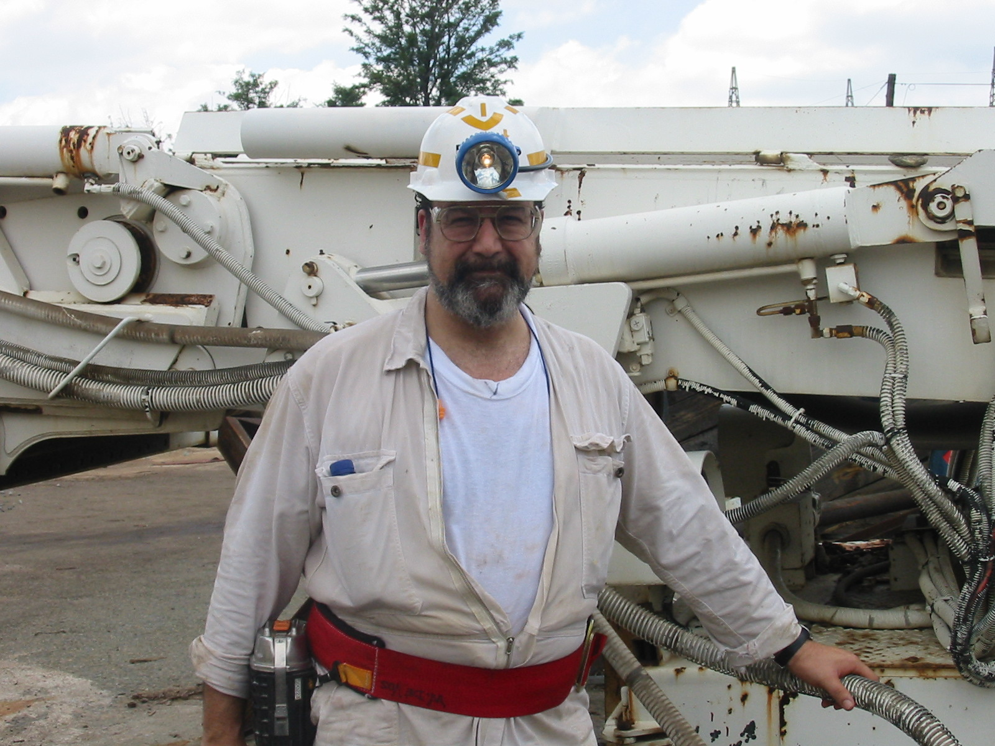
TPM is one of the most effective methods of improving the delivery of maintenance service while increasing the effectiveness of the equipment. TPM is the maintenance department's answer to the empowerment, job enrichment, and total quality programs on the production floor. The great advantage is that TPM can be incorporated into and can greatly enhance these programs. To begin with “The dual goal for TPM is zero defects and zero breakdowns." To achieve this goal TPM has four elements:

1. Maximize overall equipment effectiveness. TPM has a very strict definition of effectiveness. One of the tenants of TPM is that sloppy reading of effectiveness can cover-up opportunity for production improvement.

2. Establishes a shared system of PM for the equipment's complete life (takes into account the life cycle of the equipment). PM should be modifiable based on the life stage of the equipment. Without this, the PM tasks might not reflect the failure modes of equipment in that condition. The shared PM divides the tasks up between production and maintenance.

3. Must be implemented by all departments including maintenance, quality, engineering and tool/die design, operations, etc. Like many other programs of this type TPM is not really just a maintenance program but rather a partnership of maintenance and production. The partnership will affect all of the other stakeholders of maintenance. Their involvement is necessary for TPM to thrive. Every employee must be involved in TPM from the workers on the floor to the president.

4. TPM is based on the promotion of PM as a motivational technique through autonomous maintenance groups (operators have greater involvement and say about equipment). TPM works only because the operators begin to own the equipment. As ownership spreads then autonomous maintenance becomes a reality.

Why is the focus on PM?

Preventive Maintenance activity is the core activity of TPM teams:

To clarify: PM is a series of tasks that either,

1. Extend the life of an asset. Example: Cleaning debris out of a quick connect plug extends it’s life

-Or-

2. Through structured inspection detect that an asset has had critical wear and is going to break down and report the condition to intervene before failure.
